Form 4
Capstone Design Implementation

Title : Integrated Operational Management System for C3MR:
Web Admin Portal & Telegram Mini App Ecosystem

GROUP MEMBER:
No. | Student Name | Student ID | Study Program
1. | Auza Syamil Nabawi (Leader) | 001202300150 | Informatics
2. | Rashad Abdul Faqih | 001202300149 | Informatics
3. | Atthariqul Hazam Albanna | 012202300122 | Information System

Advisor : Dr. Adhi Setyo Santoso, ST.MBA.

Submitted for
Capstone Design Project
Faculty of Computer Science
President University
2026

TABLE OF CONTENT
STATEMENT OF ORIGINALITY
SCREENSHOT OF ZEROGPT
PART 4 : IMPLEMENTATION
A. DESIGNS IMPLEMENTATION
A.1 Backend Implementation (FastAPI + SQLAlchemy)
A.2 Database Implementation
A.3 User Interface — Web Admin Portal
A.4 User Interface — Telegram Mini App
A.5 Security Implementation
A.6 Audit & Notification Logging
A.7 Session Management & Idle Timeout
A.8 Maintenance Mode

A.9 Integration Among Modules
B. PRODUCT DISPLAY
B.1 Web Admin Portal
B.2 Telegram Mini App
B.3 Telegram Manager Bot
C. COMPONENT COST ANALYSIS
D. FUNCTIONAL TESTING
D.1 Manual Scenario Testing
D.2 Automated Test Suite (pytest) — 20 Test Cases
E. MANUAL GUIDE
E.1 System Build Documentation
REFERENCES

STATEMENT OF ORIGINALITY
In my capacity as an active student at President University and as the author of the Capstone Design Project stated below:

Name : 1. Auza Syamil Nabawi – 001202300150
2. Rashad Abdul Faqih – 001202300149
3. Atthariqul Hazam Albanna – 012202300122
Faculty : Computer Science

I hereby declare that my Capstone Design Project entitled "Integrated Operational Management System for C3MR: Web Admin Portal & Telegram Mini App Ecosystem" is to the best of my knowledge and belief, an original piece of work based on sound academic principles. If there is any plagiarism detected in this final project, I am willing to be personally responsible for the consequences of these acts of plagiarism and will accept the sanctions against these acts in accordance with the rules and policies of President University.

I also declare that this work, either in whole or in part, has not been submitted to another university to obtain a degree.

Cikarang, May 2026

Signer 1 | Signer 2 | Signer 3
Auza Syamil Nabawi  001202300150 | Rashad Abdul Faqih  001202300149 | Atthariqul Hazam Albanna  012202300122

SCREENSHOT OF ZEROGPT
[Insert ZeroGPT screenshot here]

PART 4 : IMPLEMENTATION
Consists of:
A. DESIGNS IMPLEMENTATION
B. PRODUCT DISPLAY
C. COMPONENT COST ANALYSIS
D. FUNCTIONAL TESTING
E. MANUAL GUIDE

A. DESIGNS IMPLEMENTATION

A.1 Functions/Procedure/Class Implementation — Backend
The C3MR backend is built using Python’s FastAPI framework with SQLAlchemy ORM for database operations. The application follows a modular router-based architecture where each domain (auth, dashboard, targets, users, analytics, officer) is separated into its own router module.

Main Application Entry Point (backend/main.py)
The FastAPI application is initialized in main.py. It configures restricted CORS middleware (origins controlled via CORS_ORIGINS environment variable), request logging middleware with duration tracking, security headers middleware (HSTS, X-Frame-Options, X-Content-Type-Options, X-XSS-Protection, Referrer-Policy), and a maintenance mode middleware. The maintenance middleware checks a global flag and returns HTTP 503 for all non-manager API requests when enabled — managers with valid JWT tokens can still access the system. All API routers are registered with /api prefix, and the frontend SPA is served via a catch-all middleware for non-API GET requests.
app = FastAPI(title="C3MR API")
@app.exception_handler(Exception)
async def global_exception_handler(request, exc):
logger.error(f"Unhandled error on {request.url}")
# Never expose raw exception details to clients
return JSONResponse(status_code=500,
content={"detail": "Internal server error"})
ALLOWED_ORIGINS = os.environ.get("CORS_ORIGINS",
"https://c3mr-app-production.up.railway.app").split(",")
app.mount("/officer-app", StaticFiles(directory="mini-app", html=True))
app.include_router(auth.router, prefix="/api/auth")
app.include_router(dashboard.router, prefix="/api/dashboard")
app.include_router(targets.router, prefix="/api/targets")
app.include_router(users.router, prefix="/api/users")
app.include_router(analytics.router, prefix="/api/analytics")
app.include_router(officer.router, prefix="/api/officer")
app.include_router(audit.router, prefix="/api/audit")

Authentication Router (backend/routers/auth.py)
Handles manager login via POST /api/auth/login. Accepts username and password, validates credentials against bcrypt-hashed passwords in the database, and returns a signed JWT token (HS256, 24-hour expiry). Includes server-side rate limiting: tracks login attempts per client IP using an in-memory dictionary, blocking further attempts (HTTP 429) after 5 failures within a 60-second window. Also provides POST /api/auth/verify-password (validates current password for destructive action confirmation) and POST /api/auth/change-password (requires current password verification, minimum 6-character new password, logs action to audit trail).
@router.post("/login", response_model=AuthResponse)
async def login(payload: LoginPayload, db: Session = Depends(get_db)):
user = db.query(DbUser).filter(
DbUser.email == payload.username).first()
if not user or not verify_password(
payload.password, user.password_hash):
raise HTTPException(401, "Invalid credentials")

Dashboard Router (backend/routers/dashboard.py)
Provides the GET /api/dashboard endpoint returning aggregated statistics (total, completed, in_progress, pending) and the targets list. Also provides GET /api/dashboard/recent-comments with a joined query (comments + users + targets) for the web admin’s activity feed.
@router.get("/", response_model=DashboardSnapshot)
async def get_dashboard_snapshot(db = Depends(get_db)):
total_targets = db.query(DbTarget).count()
completed = db.query(DbTarget).filter(
DbTarget.status == TargetStatus.completed).count()
targets = db.query(DbTarget).order_by(
DbTarget.created_at.desc()).limit(50).all()
return {"stats": {...}, "targets": targets}

Targets Router (backend/routers/targets.py)
Manages collection targets with JWT-protected endpoints. Key endpoints: GET /api/targets (paginated list with skip/limit and status filter), POST /api/targets/upload (bulk import from frontend CSV parser), PATCH /api/targets/{id}/assign (officer assignment with Telegram notification and audit logging), POST /api/targets/bulk-assign (assigns multiple targets to one officer in a single transaction — accepts list of target_ids and officer_id), GET /api/targets/export/csv (generates downloadable CSV file of all targets with customer name, address, phone, amount due, status, and assigned officer using StreamingResponse). All assignment operations log to audit_logs and notification_logs tables.
@router.patch("/{target_id}/assign")
async def assign_target(target_id, officer_id, db = ...):
db_target.assigned_officer = officer_id
db_target.status = TargetStatus.in_progress
db.commit()
if db_officer.telegram_id:
send_telegram_notification(db_officer.telegram_id, msg)

Users Router (backend/routers/users.py)
Manages user CRUD operations, protected by require_manager dependency (only managers can access). Includes Foreign Key cascade protection: before deleting a user, the system checks for associated targets, reports, and comments — returns HTTP 409 if linked data exists. All edit and delete operations are logged to the audit trail (DbAuditLog) with the manager's user ID, action type, and detail string.
# FK cascade protection before delete
has_targets = db.query(DbTarget).filter(
DbTarget.assigned_officer == user_id).first()
has_reports = db.query(DbReport).filter(
DbReport.officer_id == user_id).first()
has_comments = db.query(DbComment).filter(
DbComment.officer_id == user_id).first()
if has_targets or has_reports or has_comments:
raise HTTPException(status_code=409,
detail="Cannot delete user with assigned data")

Officer Router (backend/routers/officer.py)
Dedicated API for field officers via Telegram Mini App. Uses HMAC-SHA256 validation of Telegram initData for cryptographic authentication. File uploads are protected with extension whitelist (jpg, jpeg, png), 10MB size limit, and UUID filename generation to prevent path traversal attacks.
def get_current_officer(x_telegram_auth = Header(None), db = ...):
is_valid = validate_telegram_data(x_telegram_auth)
if not is_valid:
raise HTTPException(403, "Invalid Telegram Signature")
telegram_id = str(json.loads(parsed_data["user"]).get("id"))
return db.query(DbUser).filter(
DbUser.telegram_id == telegram_id).first()

Security Module (backend/security.py)
Implements dual authentication: JWT (HS256) for the Web Admin Portal with bcrypt password hashing, and HMAC-SHA256 validation of Telegram Mini App initData using constant-time comparison (hmac.compare_digest) to prevent timing attacks. Provides two access control dependencies: require_auth (any authenticated user) and require_manager (manager role only, returns 403 for officers).
def validate_telegram_data(init_data: str) -> bool:
parsed_data = dict(parse_qsl(init_data))
telegram_hash = parsed_data.pop("hash")
data_check_string = "\n".join(
f"{k}={v}" for k, v in sorted(parsed_data.items()))
secret_key = hmac.new(b"WebAppData",
bot_token.encode(), hashlib.sha256).digest()
calculated_hash = hmac.new(secret_key,
data_check_string.encode(), hashlib.sha256).hexdigest()
return hmac.compare_digest(calculated_hash, telegram_hash)
# Role-Based Access Control
require_auth = get_current_manager() # any valid JWT
require_manager = _require_manager_dep() # JWT + role == manager

Notification Service (backend/notifications.py)
Sends real-time Telegram notifications to officers when assigned a new target, using the Bot API sendMessage endpoint with Markdown formatting. Returns a boolean indicating delivery success or failure. Each notification attempt is logged in the notification_logs table with recipient, message, and success status.

Audit Router (backend/routers/audit.py)
Provides two GET endpoints for the Audit Log page: GET /api/audit/logs returns all audit trail entries (action, detail, user name, timestamp) with pagination (skip/limit). GET /api/audit/notifications returns all notification delivery logs (recipient name, message content, success/failure status, timestamp). Both endpoints join with the users table to resolve user IDs to display names. Protected by require_manager.

Manager Bot Service (backend/bot_service.py)
Standalone Telegram bot for managers using python-telegram-bot with long polling. Commands: /start (welcome + Mini App button), /summary (collection statistics), /officers (officer list with task counts). Uses @contextmanager pattern for database session management to prevent session leaks. Access control via require_manager() checks Telegram ID against registered managers in database.
from contextlib import contextmanager
@contextmanager
def get_db():
db = SessionLocal()
try:
yield db
finally:
db.close() # Always closes, even on exception
# Usage in every command handler:
async def summary_command(update, context):
with get_db() as db:
total = db.query(func.count(DbTarget.id)).scalar()
...

A.2 Database Implementation
The database uses SQLAlchemy ORM with dual-database support: SQLite for local development and PostgreSQL (Railway) for production. The DATABASE_URL environment variable controls which database is used. PostgreSQL connections enforce SSL (sslmode=require).

Entity Relationship Diagram
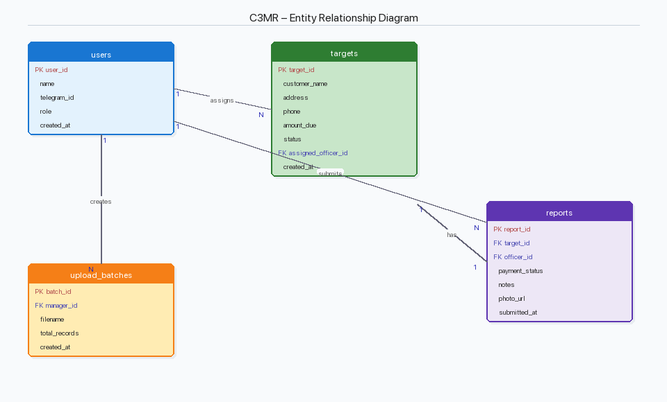
Figure A.2a — Entity Relationship Diagram
The database consists of six tables:
- users — Managers and field officers with optional Telegram ID linking, UUID primary key, name, email/username (unique), password_hash (bcrypt), and role enum (manager/officer).
- targets — Collection targets with customer data, FK assigned_officer → users.id, and status enum (pending, in_progress, completed).
- reports — Field reports with FK to targets and users, payment_status classification (Promise to Pay, Paid, Refused, Not Home, Partial Payment), notes, and photo_url.
- comments — Officer feedback with FK to targets and users, message text, and optional tag for categorization (wrong_address, wrong_phone, customer_moved, not_found, other).
- audit_logs — Audit trail with UUID primary key, FK user_id → users.id, action string (assign, edit_user, delete_user, upload, change_password), detail text, and created_at timestamp. Records every administrative action for accountability.
- notification_logs — Telegram notification delivery log with UUID primary key, FK recipient_id → users.id, message text, success flag (true/false string), and created_at timestamp. Tracks whether each notification was successfully delivered via the Bot API.

SQLAlchemy ORM Models (backend/models.py)
class DbUser(Base):
__tablename__ = "users"
id = Column(String, primary_key=True,
default=lambda: str(uuid.uuid4()))
telegram_id = Column(String, unique=True, nullable=True)
email = Column(String, unique=True, nullable=True)
password_hash = Column(String, nullable=True)
name = Column(String, nullable=False)
role = _enum_col(UserRole, "user_role")
class DbTarget(Base):
__tablename__ = "targets"
id = Column(String, primary_key=True, ...)
customer_name = Column(String, nullable=False)
address = Column(String, nullable=False)
phone = Column(String, nullable=False)
amount_due = Column(Float, nullable=False)
assigned_officer = Column(String, ForeignKey("users.id"))
status = _enum_col(TargetStatus, "target_status")
class DbReport(Base):
__tablename__ = "reports"
target_id = Column(String, ForeignKey("targets.id"))
officer_id = Column(String, ForeignKey("users.id"))
payment_status = _enum_col(PaymentStatus, ...)
notes = Column(Text); photo_url = Column(String)
class DbComment(Base):
__tablename__ = "comments"
target_id = Column(String, ForeignKey("targets.id"))
officer_id = Column(String, ForeignKey("users.id"))
message = Column(Text, nullable=False)
tag = Column(String, nullable=True)
class DbAuditLog(Base):
__tablename__ = "audit_logs"
id = Column(String, primary_key=True,
default=lambda: str(uuid.uuid4()))
user_id = Column(String, ForeignKey("users.id"))
action = Column(String, nullable=False)
detail = Column(Text, nullable=True)
created_at = Column(DateTime,
default=lambda: datetime.now(timezone.utc))
class DbNotificationLog(Base):
__tablename__ = "notification_logs"
id = Column(String, primary_key=True,
default=lambda: str(uuid.uuid4()))
recipient_id = Column(String, ForeignKey("users.id"))
message = Column(Text, nullable=False)
success = Column(String, default="true")
created_at = Column(DateTime,
default=lambda: datetime.now(timezone.utc))

A.3 User Interface Implementation — Web Admin Portal
Built with React 18 + TypeScript, Vite build tool, Tailwind CSS with dark mode support (class-based toggle with CSS custom properties), react-router-dom v7, Axios with JWT interceptors, and PapaParse for CSV parsing. Includes an ErrorBoundary for crash recovery. The AppShell layout component provides consistent navigation, dark mode toggle, change password modal, and maintenance mode controls across all pages.

Page Components
LoginPage — Username/password login with password visibility toggle (eye icon), client-side brute force protection (5 attempts / 60-second lockout via localStorage), Recovery Options modal with admin reset and re-seed instructions, loading spinner animation, and automatic redirect if already authenticated.
DashboardPage — Operational command center. Four summary cards (Total Targets, Completed, In Progress, Pending). Three operational panels: 'Needs Assignment' (red header, lists unassigned targets), 'Active Assignments' (amber header, shows in-progress targets with officer names), and 'Officer Feedback' (latest comments with issue tags). Active Officers section shows initials, assigned count, and completion count per officer. Real-time data refresh every 10 seconds.
TargetsPage — Full target inventory with search filter (by name/ID) and status filter dropdown (All, Pending, In Progress, Completed). CSV upload panel with column validation and preview. Export CSV button downloads all targets as a .csv file. Bulk assign feature: checkbox column on pending targets, select multiple, choose officer from dropdown, assign all in one action. View Details modal shows full target info, field reports with photo evidence, and officer comments with issue tags.
AnalyticsPage — Revenue overview with three metric boxes (Total Outstanding, Collected, Outstanding) and collection progress bar with percentage. Status breakdown with colored border-left indicators (red/amber/green) showing count and percentage per status. Officer performance ranking with horizontal bar chart (completed vs assigned). Activity summary and reported field issues sections. Date range filter (from/to) for all metrics.
UserManagementPage — Officer registration form with name and Telegram ID fields. Personnel directory table with role, Telegram ID, assigned/completed counts, and edit/remove actions. Password confirmation modal: before any edit or delete operation, the manager must enter their current password (validated via /api/auth/verify-password) to prevent unauthorized modifications. Telegram link status shows how many officers are linked vs unlinked.
AuditLogPage — Two-tab interface: 'Activity Log' shows all administrative actions (assign, upload, edit user, delete user, change password) with actor name, detail, and timestamp. 'Notifications' tab shows all Telegram notification deliveries with recipient name, message preview, success/failure badge, and timestamp. Both tabs paginate up to 100 entries.
AppShell (Layout) — Persistent layout wrapper with responsive header, dark mode toggle (desktop: Dark/Light button, mobile: DK/LT), navigation tabs (Dashboard, Analytics, User Management, Targets, Audit Log), change password modal (current + new password fields), maintenance mode toggle with custom message input, and logout button. Mobile hamburger menu with full navigation. Amber banner displayed when maintenance mode is active. 5-minute idle session timeout: listens for mousedown, keydown, touchstart, and scroll events — automatically logs out the user after 5 minutes of inactivity.

Login Page Security Features
// Client-side brute force protection
const MAX_ATTEMPTS = 5;
const LOCKOUT_MS = 60_000; // 60 seconds
// On failed login:
recordFailure(); // increment counter in localStorage
const remaining = MAX_ATTEMPTS - failures.count;
setError(`${message} (${remaining} attempts remaining)`);
// On 5th failure:
setError("Account temporarily locked. Try again in 60s.");
// Form inputs and submit button disabled
// On successful login:
clearFailures(); // reset counter

Server-Side Rate Limiting (backend/routers/auth.py)
In addition to client-side lockout, the backend implements server-side rate limiting per IP address. A dictionary tracks login attempt timestamps per client IP. After 5 failed attempts within 60 seconds, the server returns HTTP 429 (Too Many Requests) regardless of client-side state. This prevents bypass via direct API calls or clearing localStorage.
# Server-side rate limiting
_login_attempts: dict[str, list[float]] = defaultdict(list)
def _check_rate_limit(client_ip: str):
now = time.time()
_login_attempts[client_ip] = [
t for t in _login_attempts[client_ip]
if now - t < 60
]
if len(_login_attempts[client_ip]) >= 5:
raise HTTPException(429, "Too many attempts")

Authentication Context (AuthContext.tsx)
React Context API manages authentication state globally. On page load, readStoredUser() retrieves the JWT from localStorage, decodes the payload, and checks the exp field. If expired, the user is automatically logged out. The AuthProvider also implements a 5-minute idle session timeout: event listeners on mousedown, keydown, touchstart, and scroll reset a setTimeout timer. After 5 minutes of inactivity, logout() is called automatically, removing the token and redirecting to the login page.

A.4 User Interface Implementation — Telegram Mini App
Single-page app built with vanilla HTML/CSS/JavaScript, served at /officer-app. Uses Telegram Web App SDK for native integration (haptic feedback, back button, main button). Includes localStorage-based offline caching with 24-hour TTL for tasks and comments.

Application Views
- Loading View — Animated spinner during initialization.
- Login View — Manual Telegram ID entry fallback for browser testing.
- List View — Assignment queue with task cards: case number, customer name, address, priority badge (red/yellow/blue based on amount), amount, 'Process Report' button.
- Detail View — Report form: subject data card, classification dropdown (Promise to Pay, Paid, Refused, Not Home, Partial Payment), officer narrative, photo capture, issue report section with tag buttons (Alamat Salah, Nomor Salah, Customer Pindah, Tidak Ditemukan, Lainnya), comment history, and 'Finalize Submission' button.

XSS Prevention
Because the Mini App uses vanilla JavaScript (not React’s auto-escape), a manual esc() function is implemented to prevent Cross-Site Scripting:
function esc(str) {
const d = document.createElement('div');
d.textContent = str; // Browser auto-escapes
return d.innerHTML; // Returns escaped string
}
// Usage: '<div>' + esc(task.customerName) + '</div>'

A.5 Security Implementation
As a cybersecurity-focused capstone project, the following security controls are implemented across the system, mapped to OWASP Top 10 2021 categories:
A01 Broken Access Control: Role-Based Access Control with two levels: require_auth (any valid JWT) and require_manager (JWT + manager role). Officers attempting to access manager endpoints receive HTTP 403. FK cascade protection prevents orphan data on user deletion (409).
A02 Cryptographic Failures: Bcrypt adaptive password hashing (cost factor 12). JWT HS256 token signing with server-side SECRET_KEY. HMAC-SHA256 Telegram initData validation with constant-time comparison (hmac.compare_digest) to prevent timing attacks.
A03 Injection: SQLAlchemy ORM ensures all queries are parameterized (prevents SQL injection). React auto-escapes JSX output (prevents XSS in Web Admin). Manual esc() function in Mini App prevents XSS in vanilla JavaScript rendering.
A04 Insecure Design: Structured input forms with dropdowns and enums (not free text). Pydantic server-side validation on all request bodies. File extension whitelist (.jpg, .jpeg, .png).
A05 Security Misconfiguration: CORS whitelist (not allow-all). DEBUG mode disabled in production. Secret keys via environment variables (not hardcoded). No stack traces in error responses.
A07 Authentication Failures: JWT 24-hour expiry. Bcrypt with adaptive cost factor. Dual rate limiting: client-side (5 attempts / 60-second lockout via localStorage) AND server-side (per-IP attempt tracking, HTTP 429 after 5 failures). 5-minute idle session timeout with automatic logout. Password confirmation required before edit/delete user operations. UUID primary keys prevent IDOR.
A08 Data Integrity Failures: HMAC-SHA256 validates Telegram data authenticity (anti-spoofing). UUID filenames prevent path traversal. 10MB upload limit prevents DoS.
A09 Security Logging and Monitoring: All administrative actions (assign, upload, edit, delete, password change) are recorded in the audit_logs table with user ID, action type, detail, and timestamp. Telegram notification delivery outcomes are logged in notification_logs. The Audit Log page provides real-time visibility into system activity for managers.
A10 Service Availability Controls: Maintenance mode middleware allows managers to disable all non-manager API access with a single toggle. When enabled, the system returns HTTP 503 with a custom message for all unauthenticated and non-manager requests. Manager sessions remain fully functional. Bypass paths include login and maintenance status endpoints to ensure managers can always authenticate and toggle the mode off.

A.6 Audit & Notification Logging
Every administrative action in the system is recorded in the audit_logs table for accountability and compliance. The following actions trigger audit entries:
- assign — When a manager assigns an officer to a target (single or bulk). Detail includes target customer name and officer name.
- upload — When a manager uploads CSV targets. Detail includes the number of records imported.
- edit_user — When a manager edits an officer’s name or Telegram ID.
- delete_user — When a manager removes a user from the system.
- change_password — When a manager changes their own login password.
Telegram notifications are logged in the notification_logs table. Each entry records the recipient, message content, and whether the Bot API delivery succeeded (true) or failed (false). This allows managers to verify notification delivery on the Audit Log page’s Notifications tab.

A.7 Session Management & Idle Timeout
The Web Admin Portal implements a 5-minute idle session timeout via the AuthContext. Event listeners on mousedown, keydown, touchstart, and scroll reset a setTimeout timer. If no user interaction occurs within 5 minutes, the logout() function is called automatically — removing the JWT from localStorage and redirecting to the login page. This mitigates session hijacking risk on shared or unattended workstations.
// Idle timeout implementation (AuthContext.tsx)
const IDLE_TIMEOUT_MS = 5 * 60 * 1000;
const resetIdleTimer = useCallback(() => {
if (timerRef.current) clearTimeout(timerRef.current);
timerRef.current = setTimeout(logout, IDLE_TIMEOUT_MS);
}, [logout]);
useEffect(() => {
const events = ["mousedown", "keydown", "touchstart", "scroll"];
events.forEach(e => window.addEventListener(e, resetIdleTimer));
return () => events.forEach(e => window.removeEventListener(e, resetIdleTimer));
}, [user]);

A.8 Maintenance Mode
The system includes a maintenance mode feature that allows managers to temporarily disable all external access to the API. This is useful during data migrations, system updates, or emergency situations.
Implementation: A global MaintenanceState object (backend/maintenance.py) holds the enabled flag and custom message. The MaintenanceMiddleware (backend/main.py) intercepts all /api/* requests. When maintenance is enabled:
- Non-manager requests receive HTTP 503 (Service Unavailable) with the custom message.
- Manager requests (identified by valid JWT with role=manager) pass through normally.
- Bypass paths (/api/auth/login, /api/admin/maintenance) remain accessible so managers can authenticate and toggle the mode off.
The frontend displays an amber banner at the top of the page when maintenance is active. The toggle is accessible from the navigation bar with a custom message input field.
# Maintenance middleware (backend/main.py)
class MaintenanceMiddleware(BaseHTTPMiddleware):
async def dispatch(self, request, call_next):
if maintenance_state.enabled and \
request.url.path.startswith('/api'):
auth = request.headers.get('authorization', '')
is_manager = False
if auth.startswith('Bearer '):
token = auth.split(' ', 1)[1]
payload = decode_access_token(token)
is_manager = payload.get('role') == 'manager'
if not is_manager:
return JSONResponse(503,
{'detail': maintenance_state.message})

A.9 Integration Among Modules

System Architecture
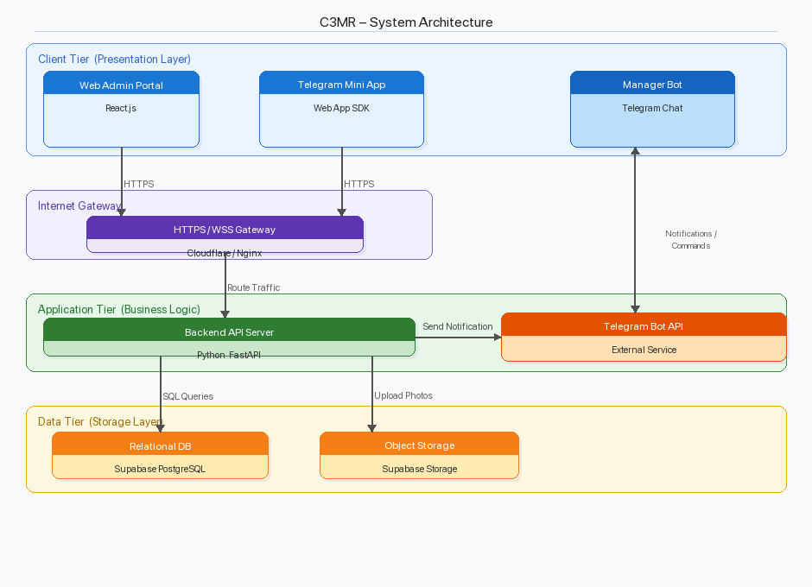
Figure A.9a — System Architecture Diagram (3-Tier)

Component Interaction
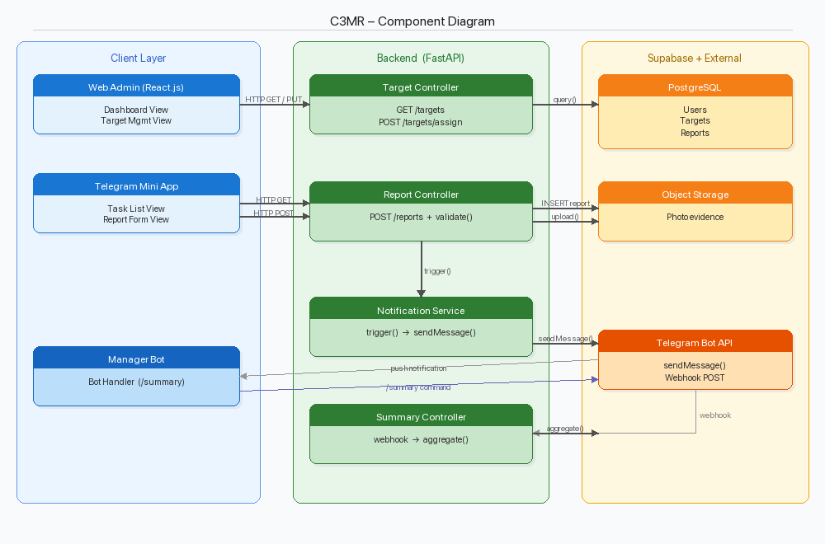
Figure A.9b — Component Diagram
1. Web Admin Portal ↔ Backend API: React frontend communicates via Axios RESTful calls through /api prefix. An Axios request interceptor automatically attaches the JWT Bearer token to every request. API base URL configured via VITE_API_BASE_URL environment variable, defaulting to /api for same-origin deployment.
2. Telegram Mini App ↔ Backend API: Uses Fetch API with X-Telegram-Auth header for cryptographic authentication. Accesses /api/officer/* endpoints for tasks, reports (multipart/form-data with photo), and comments.
3. Backend → Telegram Bot API: When manager assigns a target, backend sends push notification to officer’s Telegram via Bot API sendMessage. Manager Bot queries database for /summary and /officers using context manager pattern.
4. Shared Database Layer: All components share the same PostgreSQL database through SQLAlchemy ORM, ensuring data consistency. Changes in any interface are immediately visible in others.

B. PRODUCT DISPLAY

B.1 Web Admin Portal
9. Bulk Assign: On Targets page, check multiple pending targets, select an officer from the dropdown, click 'Assign All' to assign them in one action.
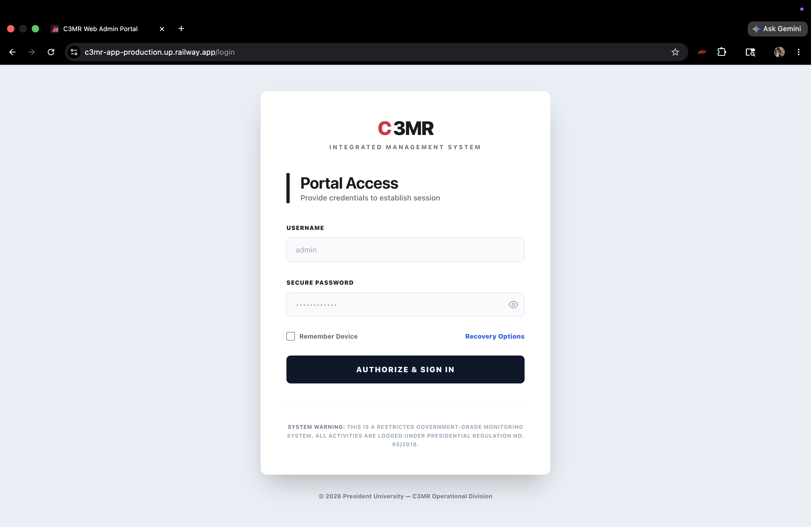
Figure B.1a — Web Admin Portal — Login Page
Features C3MR branding with radar/signal logo, username/password fields with password visibility toggle, 'Remember Device' checkbox, Recovery Options modal, and security notice. After 5 failed attempts, the form is locked for 60 seconds (both client-side and server-side enforcement).

10. Change Password: Click 'Password' in the navigation bar, enter current and new password.
# Clone and install
git clone https://github.com/asn95/capstone1.git && cd capstone1
pip install -r requirements.txt
# Configure environment (.env)
DATABASE_URL=sqlite:///./c3mr.db
JWT_SECRET=<your-secret-key>
CORS_ORIGINS=http://localhost:5173
TELEGRAM_BOT_TOKEN=<your_token>
SEED_TOKEN=<your_seed_token>
# Start server (tables auto-created on first run)
uvicorn backend.main:app --host 0.0.0.0 --port 8000 --reload
# Seed admin account
curl -X POST http://localhost:8000/api/auth/seed-admin \
-H "Content-Type: application/json" \
-d '{"token": "<SEED_TOKEN>"}'
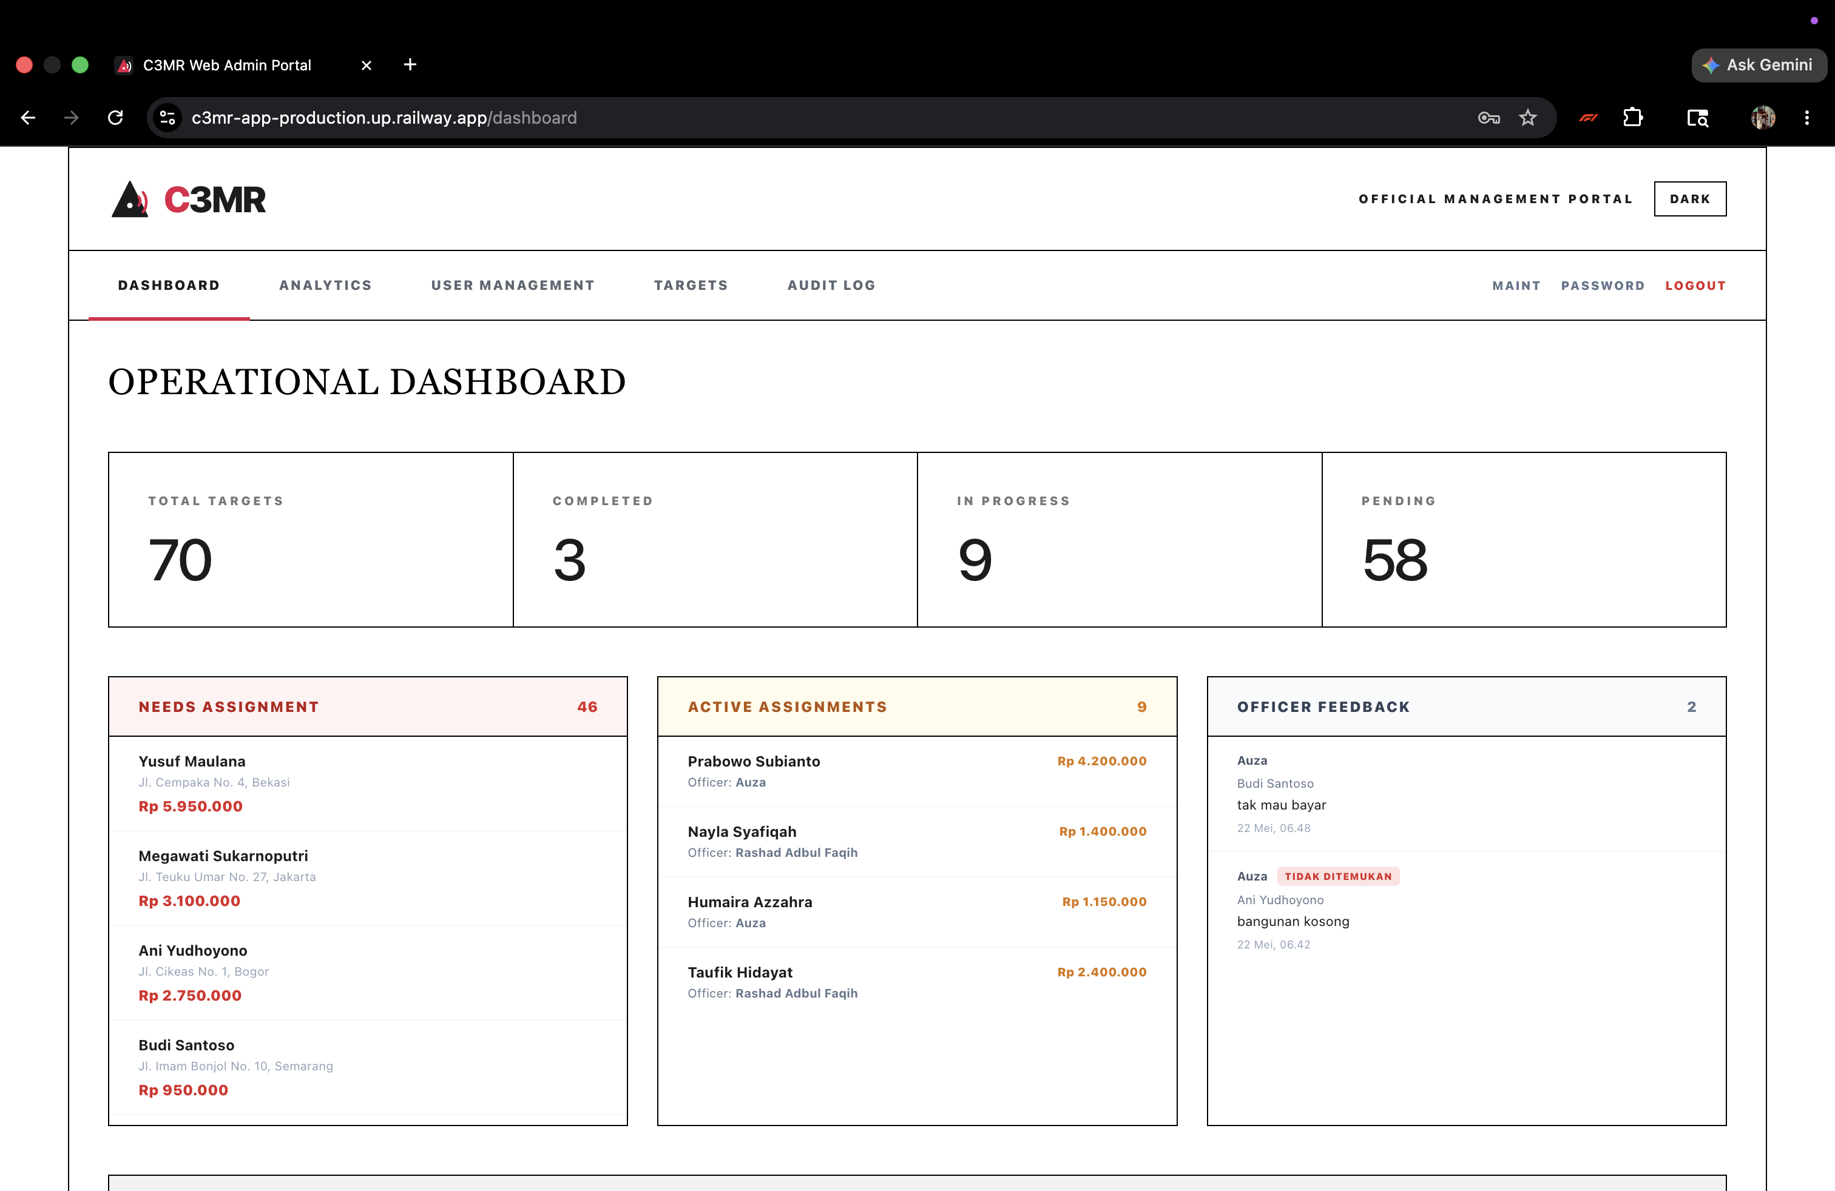
Figure B.1b — Web Admin Portal — Operational Dashboard
Four summary cards (Total Targets, Completed, In Progress, Pending). Three operational panels: Needs Assignment (unassigned targets), Active Assignments (in-progress with officer names), and Officer Feedback (recent comments with issue tags). Active Officers section at bottom.

11. Audit Log: Navigate to Audit Log page to review all administrative actions and notification delivery history.
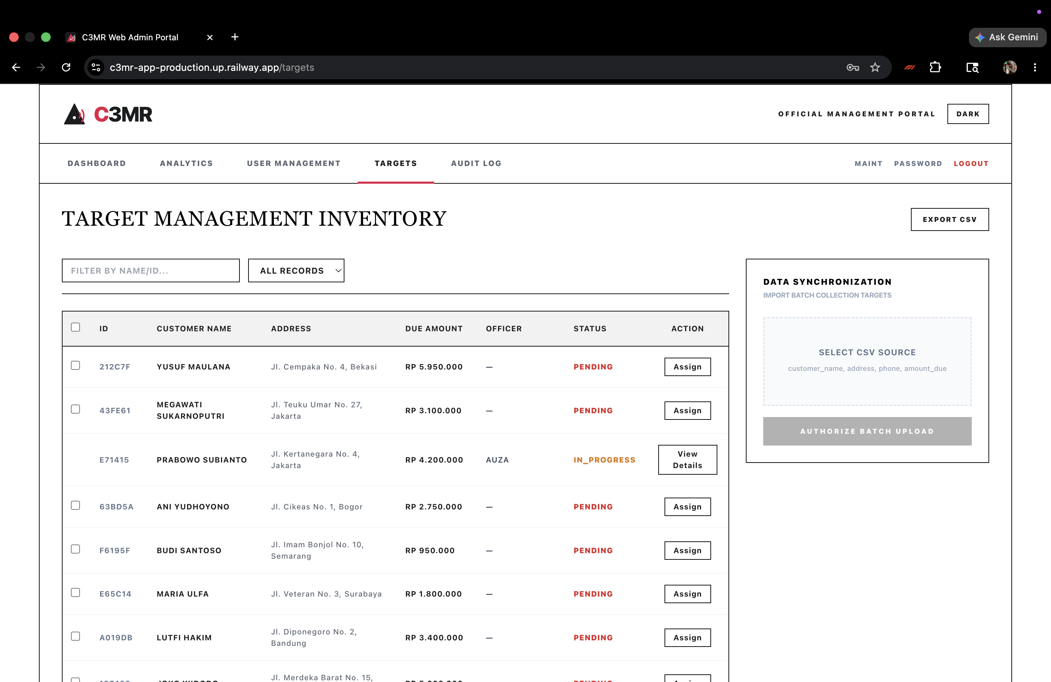
Figure B.1c — Web Admin Portal — Target Management Page
Target inventory with search by name/ID, status filter dropdown, Export CSV button, bulk assign bar (select multiple pending targets → choose officer → Assign All), and CSV upload panel with preview.

12. Dark Mode: Click 'Dark/Light' button in the header to toggle dark theme. Preference is saved across sessions.
cd frontend && npm install
echo "VITE_API_BASE_URL=http://localhost:8000/api" > .env
npm run dev # Available at http://localhost:5173
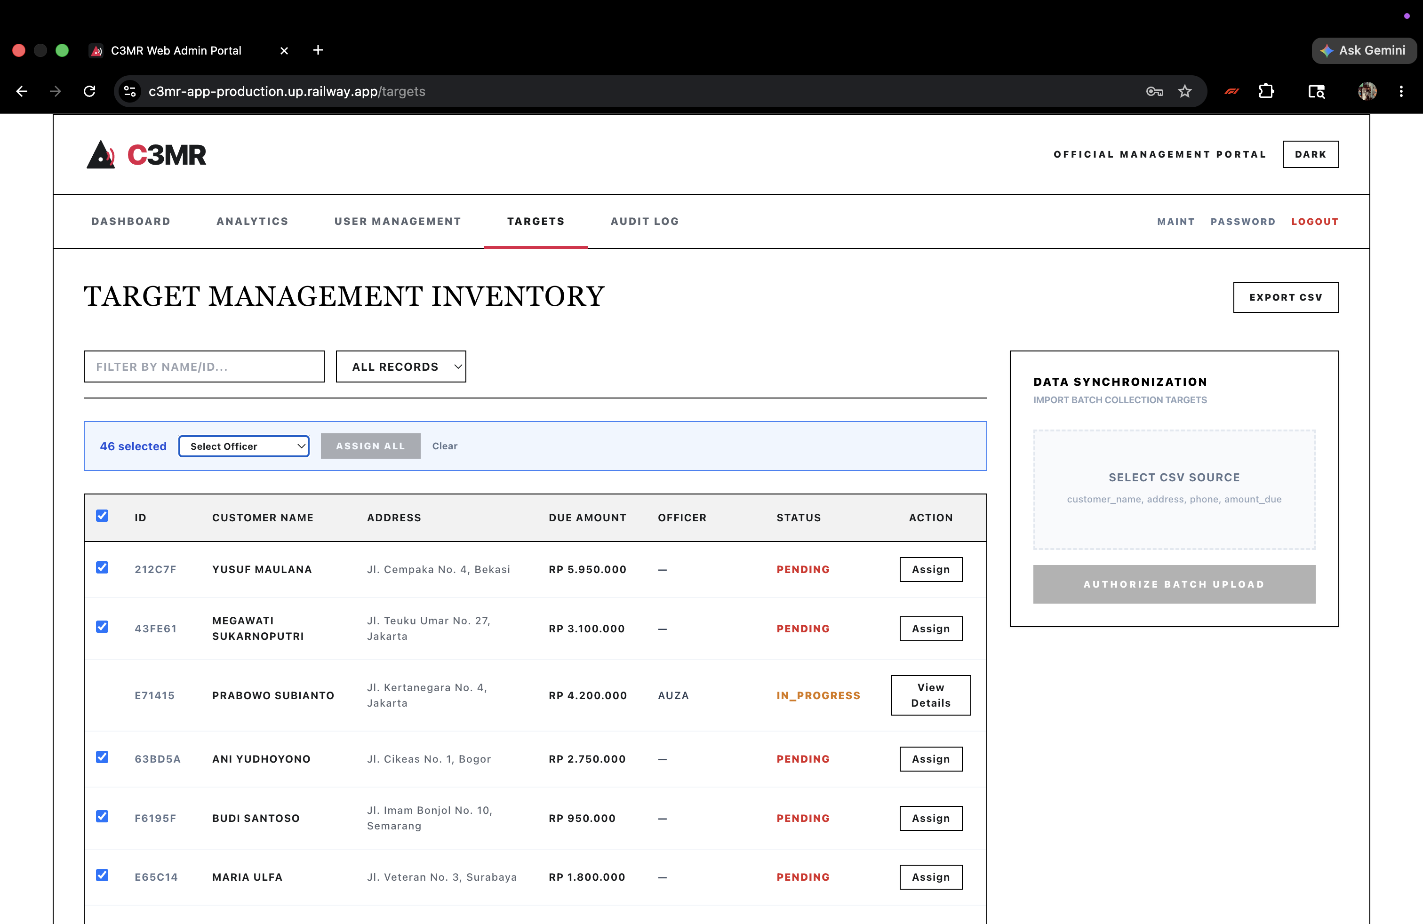
Figure B.1d — Web Admin Portal — Bulk Assign Feature

13. Session Timeout: The system automatically logs out after 5 minutes of inactivity for security.
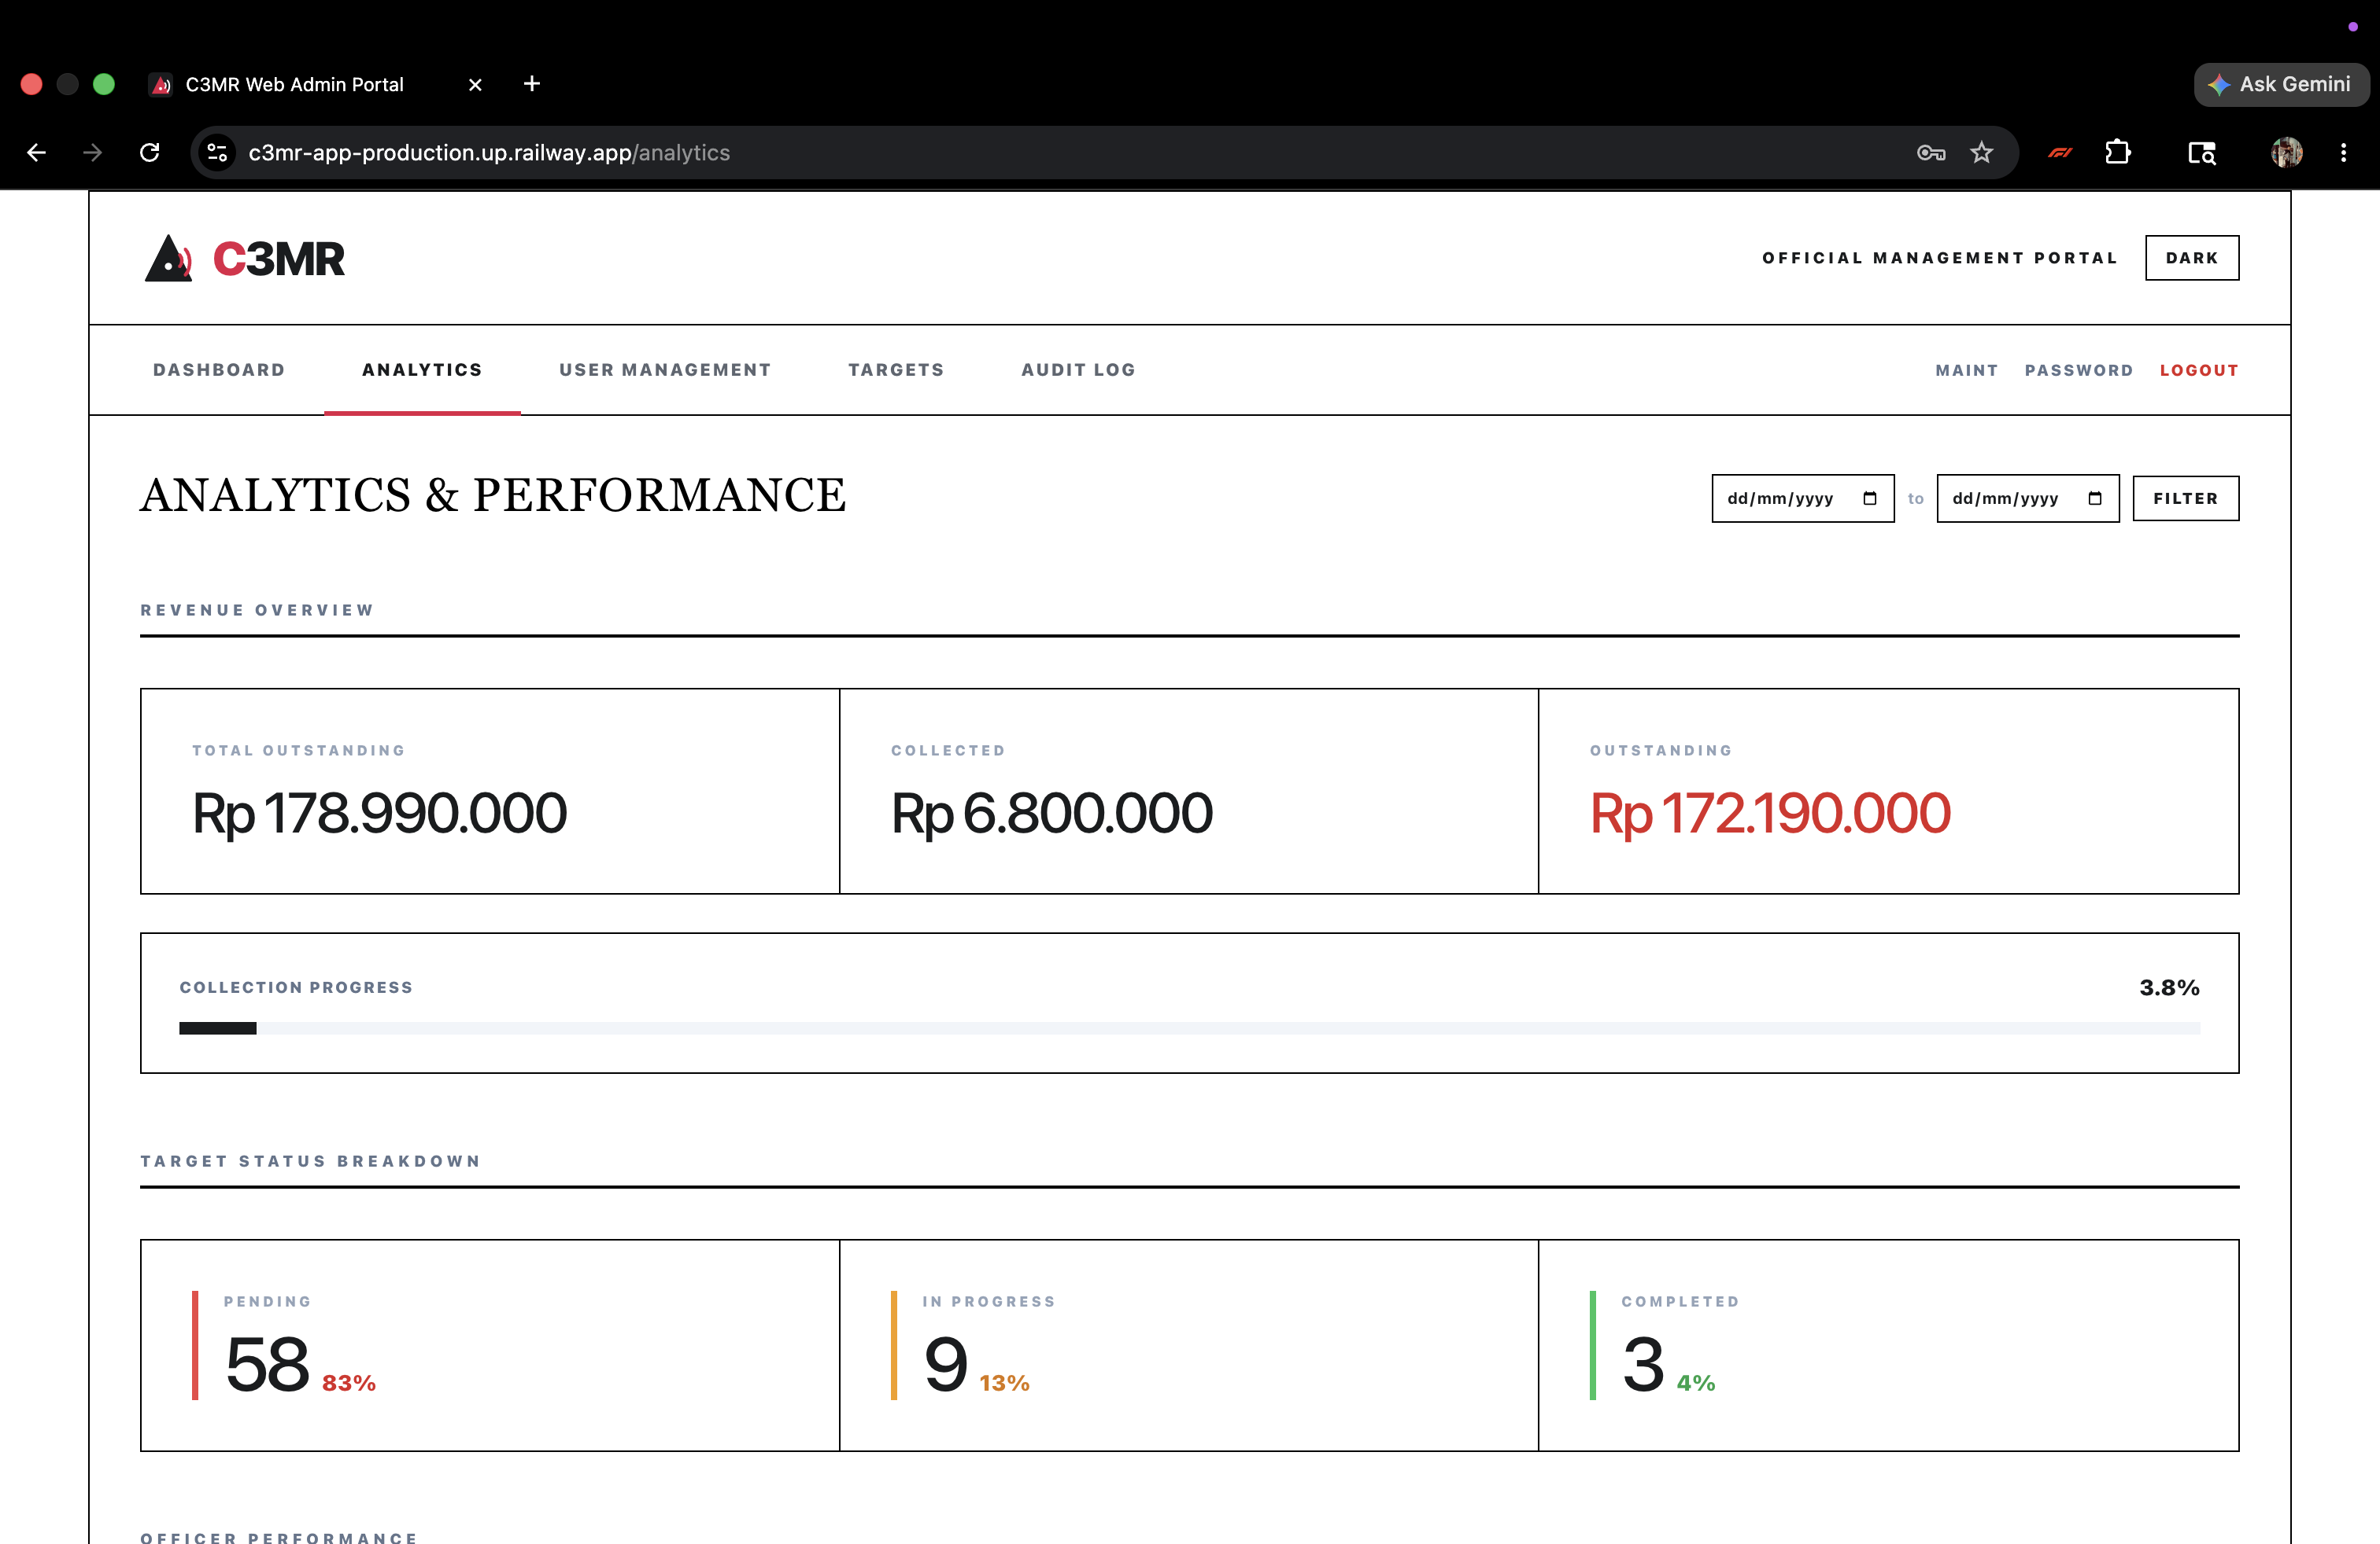
Figure B.1e — Web Admin Portal — Analytics Page
Revenue overview (Total Outstanding, Collected, Outstanding), collection progress bar, status breakdown with percentages, officer performance ranking, activity summary, and reported field issues. Date range filter (from/to) for time-bounded analysis.

14. Maintenance Mode: Click 'Maint' in the navigation bar to open the maintenance toggle. Enter a custom message and click 'Enable Maintenance' to block all non-manager access. An amber banner confirms the mode is active. Click 'Disable Maintenance' to restore normal access.
railway login && railway link
# Set environment variables via Railway dashboard
# Push to GitHub -> Railway auto-deploys from Dockerfile
# Services: c3mr-app (Dockerfile), c3mr-bot (Dockerfile.bot)
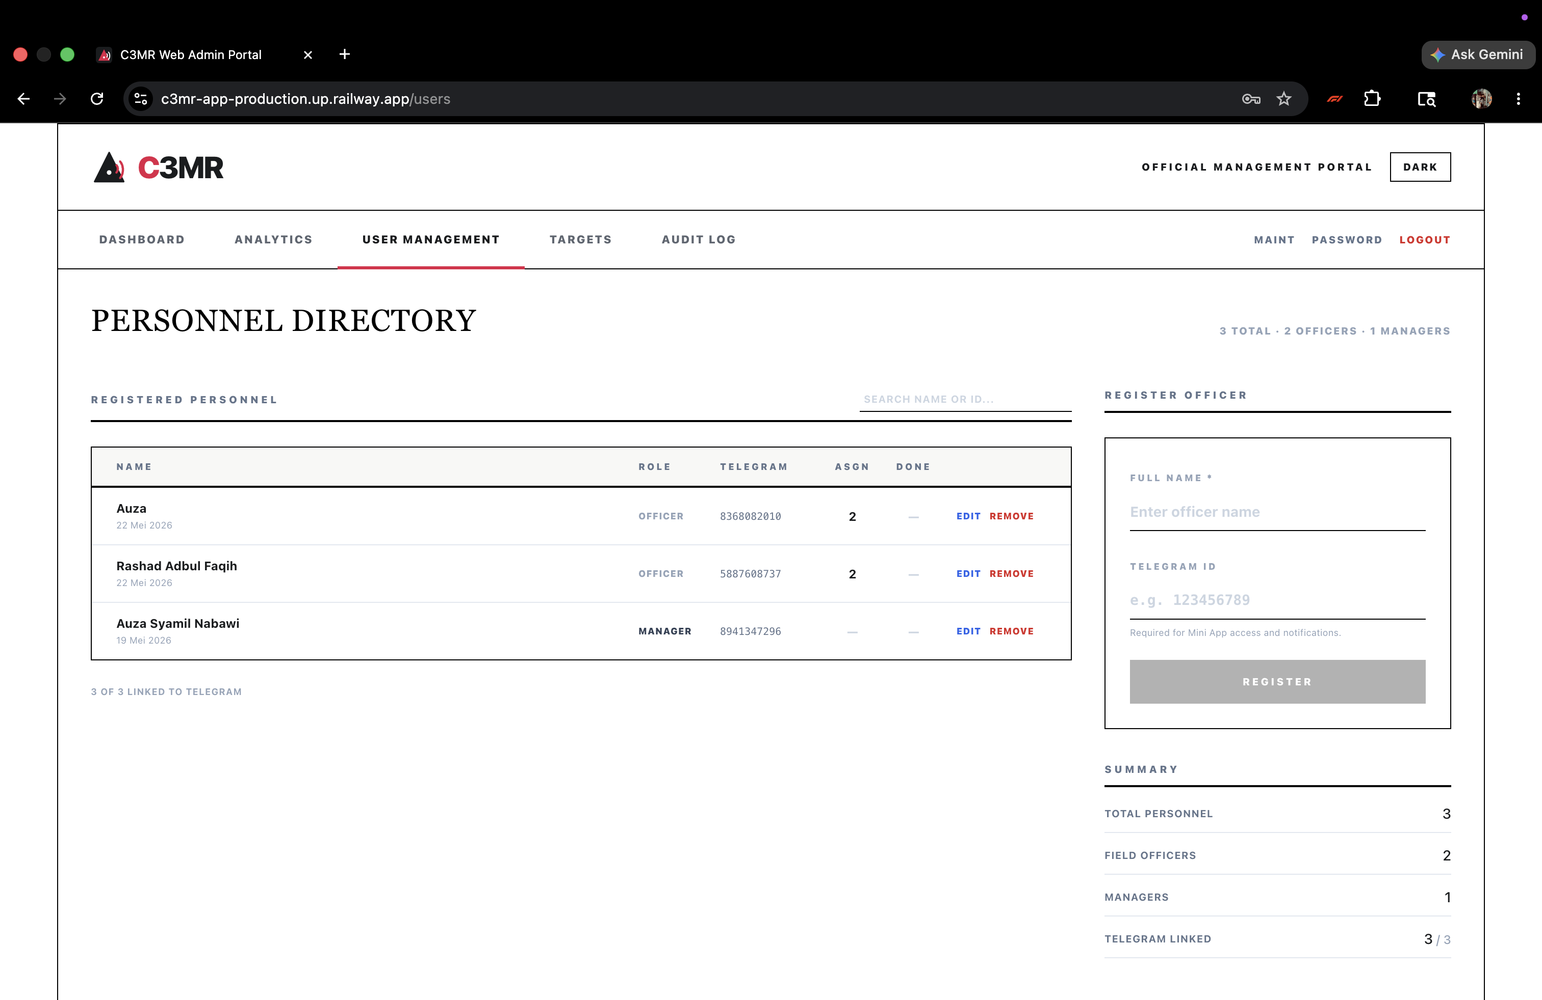
Figure B.1f — Web Admin Portal — User Management Page
Personnel directory with edit/remove actions (password confirmation required), officer registration form, Telegram link status indicator, and summary statistics.

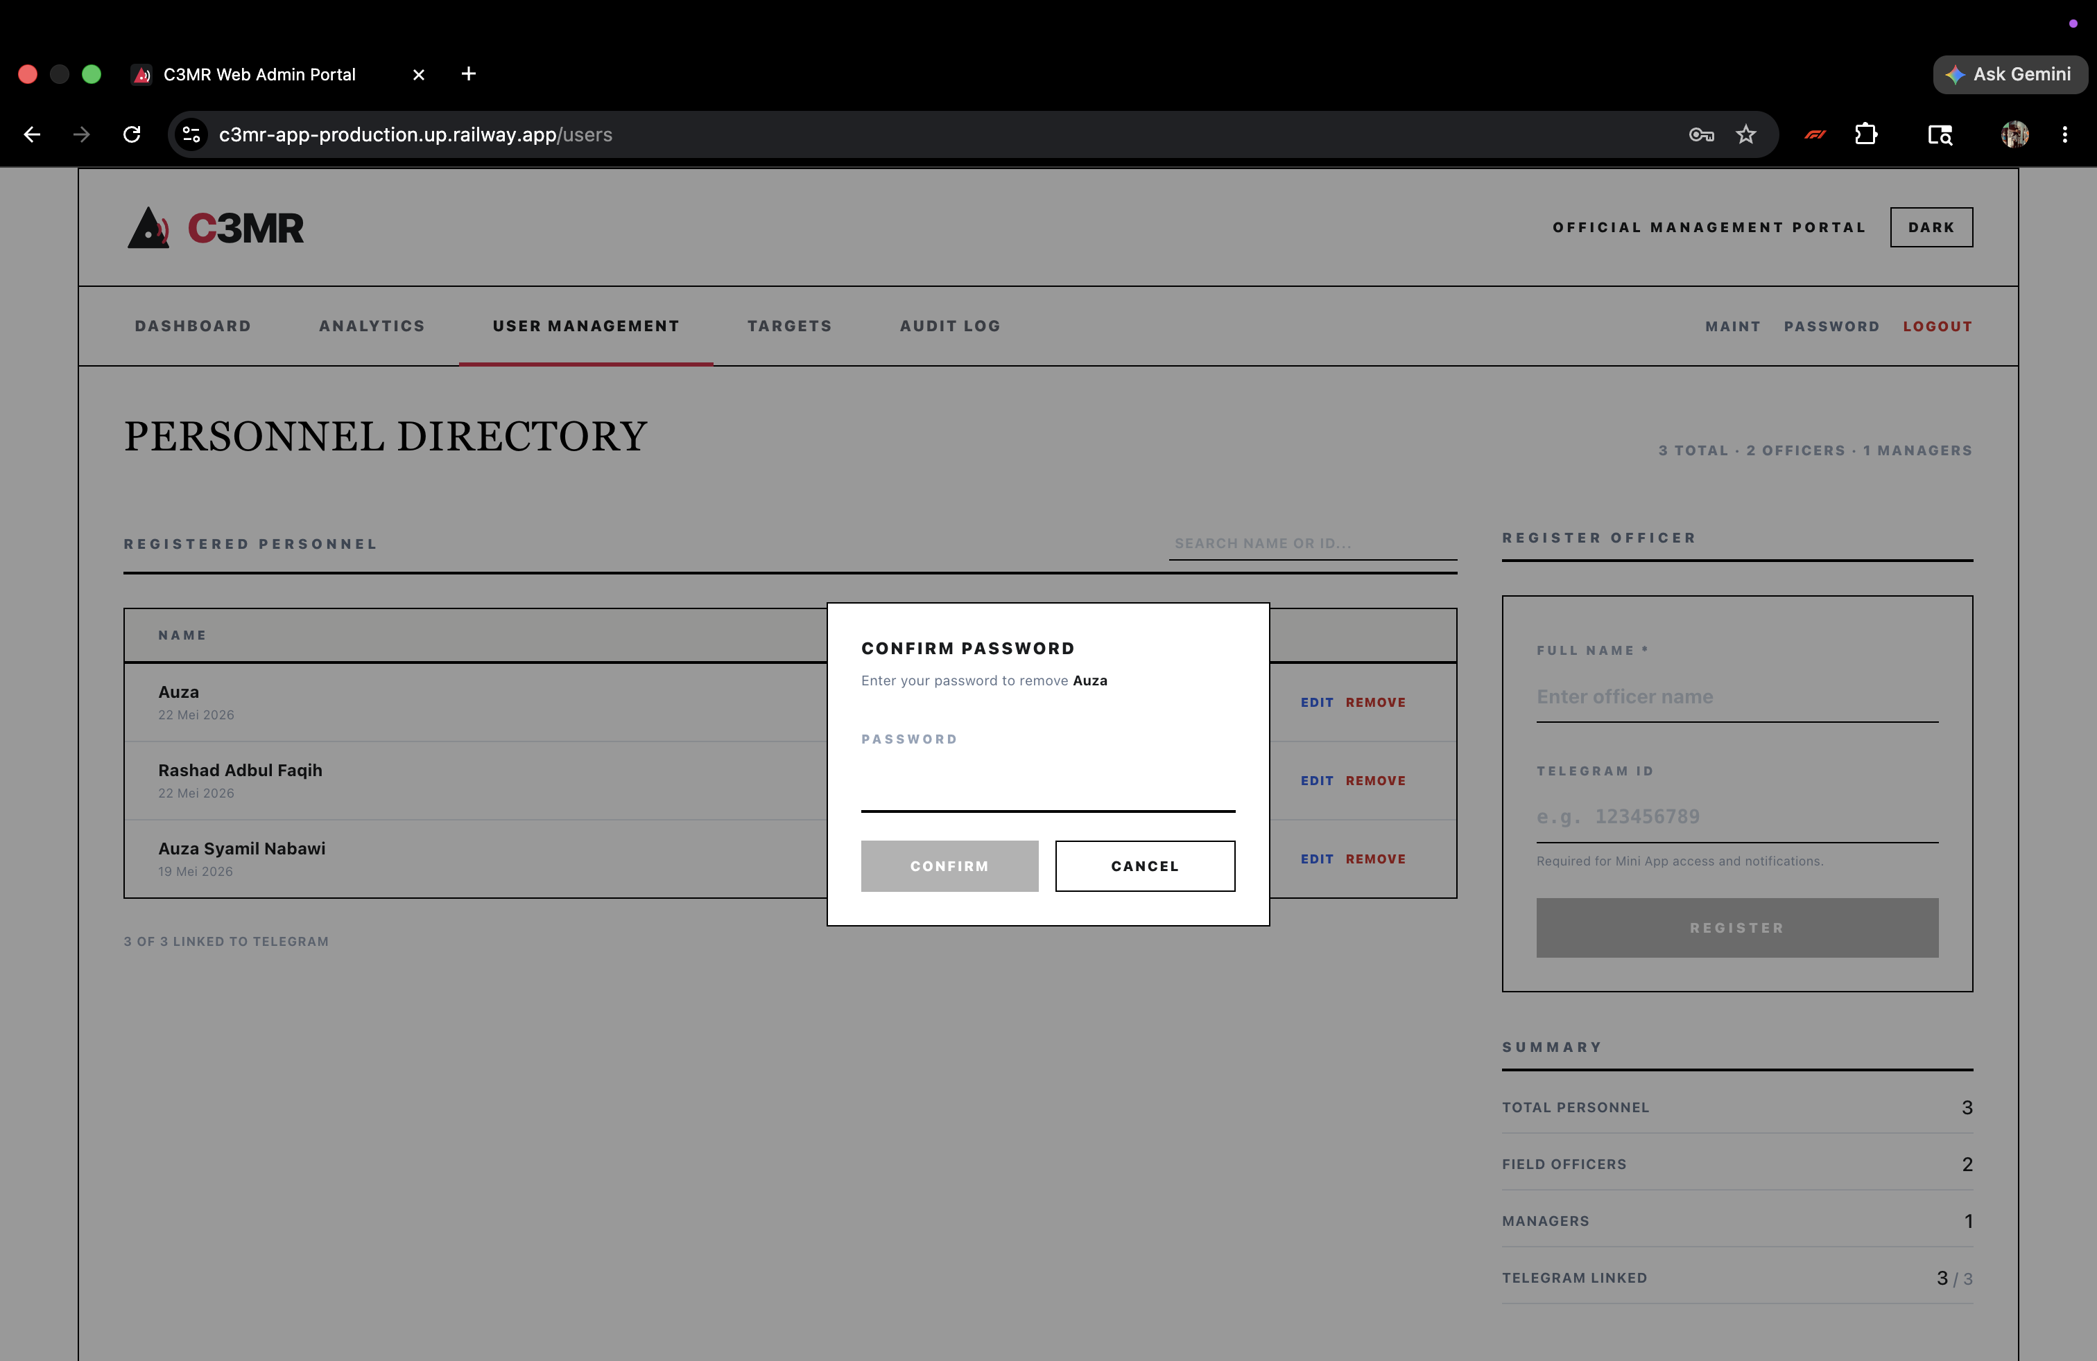
Figure B.1g — Web Admin Portal — Password Confirmation Modal

1. Open Mini App: Open the bot in Telegram, tap Menu button. Identity verified automatically via Telegram cryptographic signature.
C3MR is web-based and requires no software installation for end users. The following table shows the minimum requirements per user role:
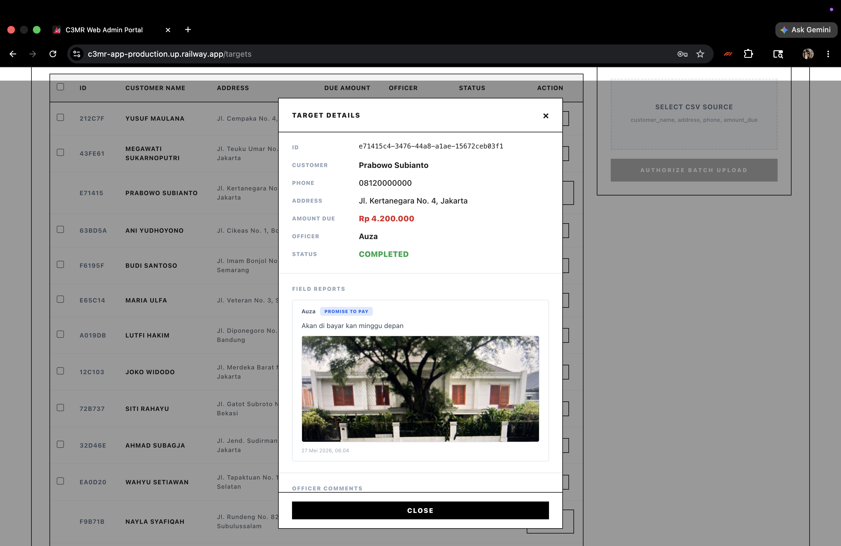
Figure B.1h — Web Admin Portal — View Details Modal

2. View Assignments: Main screen shows task cards with case number, customer info, priority badge (by amount), and balance due.
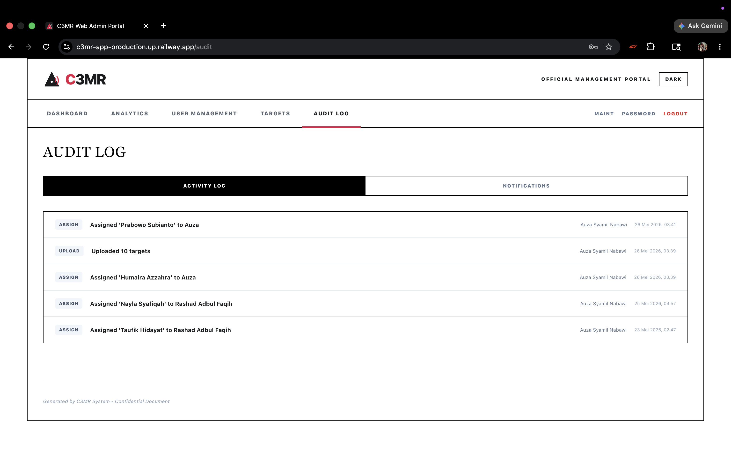
Figure B.1i — Web Admin Portal — Audit Log Page (Activity Tab)

3. Submit Report: Tap 'Process Report', select payment classification, write observation notes, capture photo evidence, tap 'Finalize Submission'.
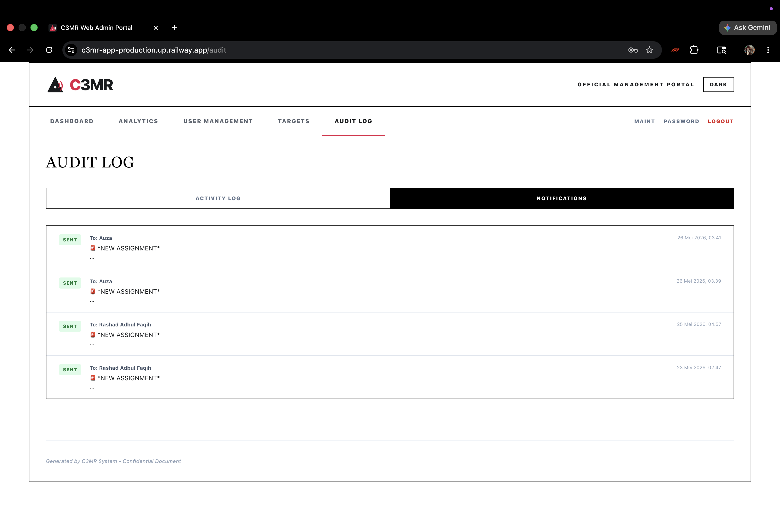
Figure B.1j — Web Admin Portal — Audit Log Page (Notifications Tab)

4. Report Issue: Scroll to 'Issue Report' section, select tag (Alamat Salah, Nomor Salah, Customer Pindah, Tidak Ditemukan, Lainnya), write comment, tap 'Kirim Komentar'.
1. Login: Open the portal URL, enter username and password, click 'Authorize & Sign In'. Password visibility toggle available. After 5 failed attempts, account locks for 60 seconds.
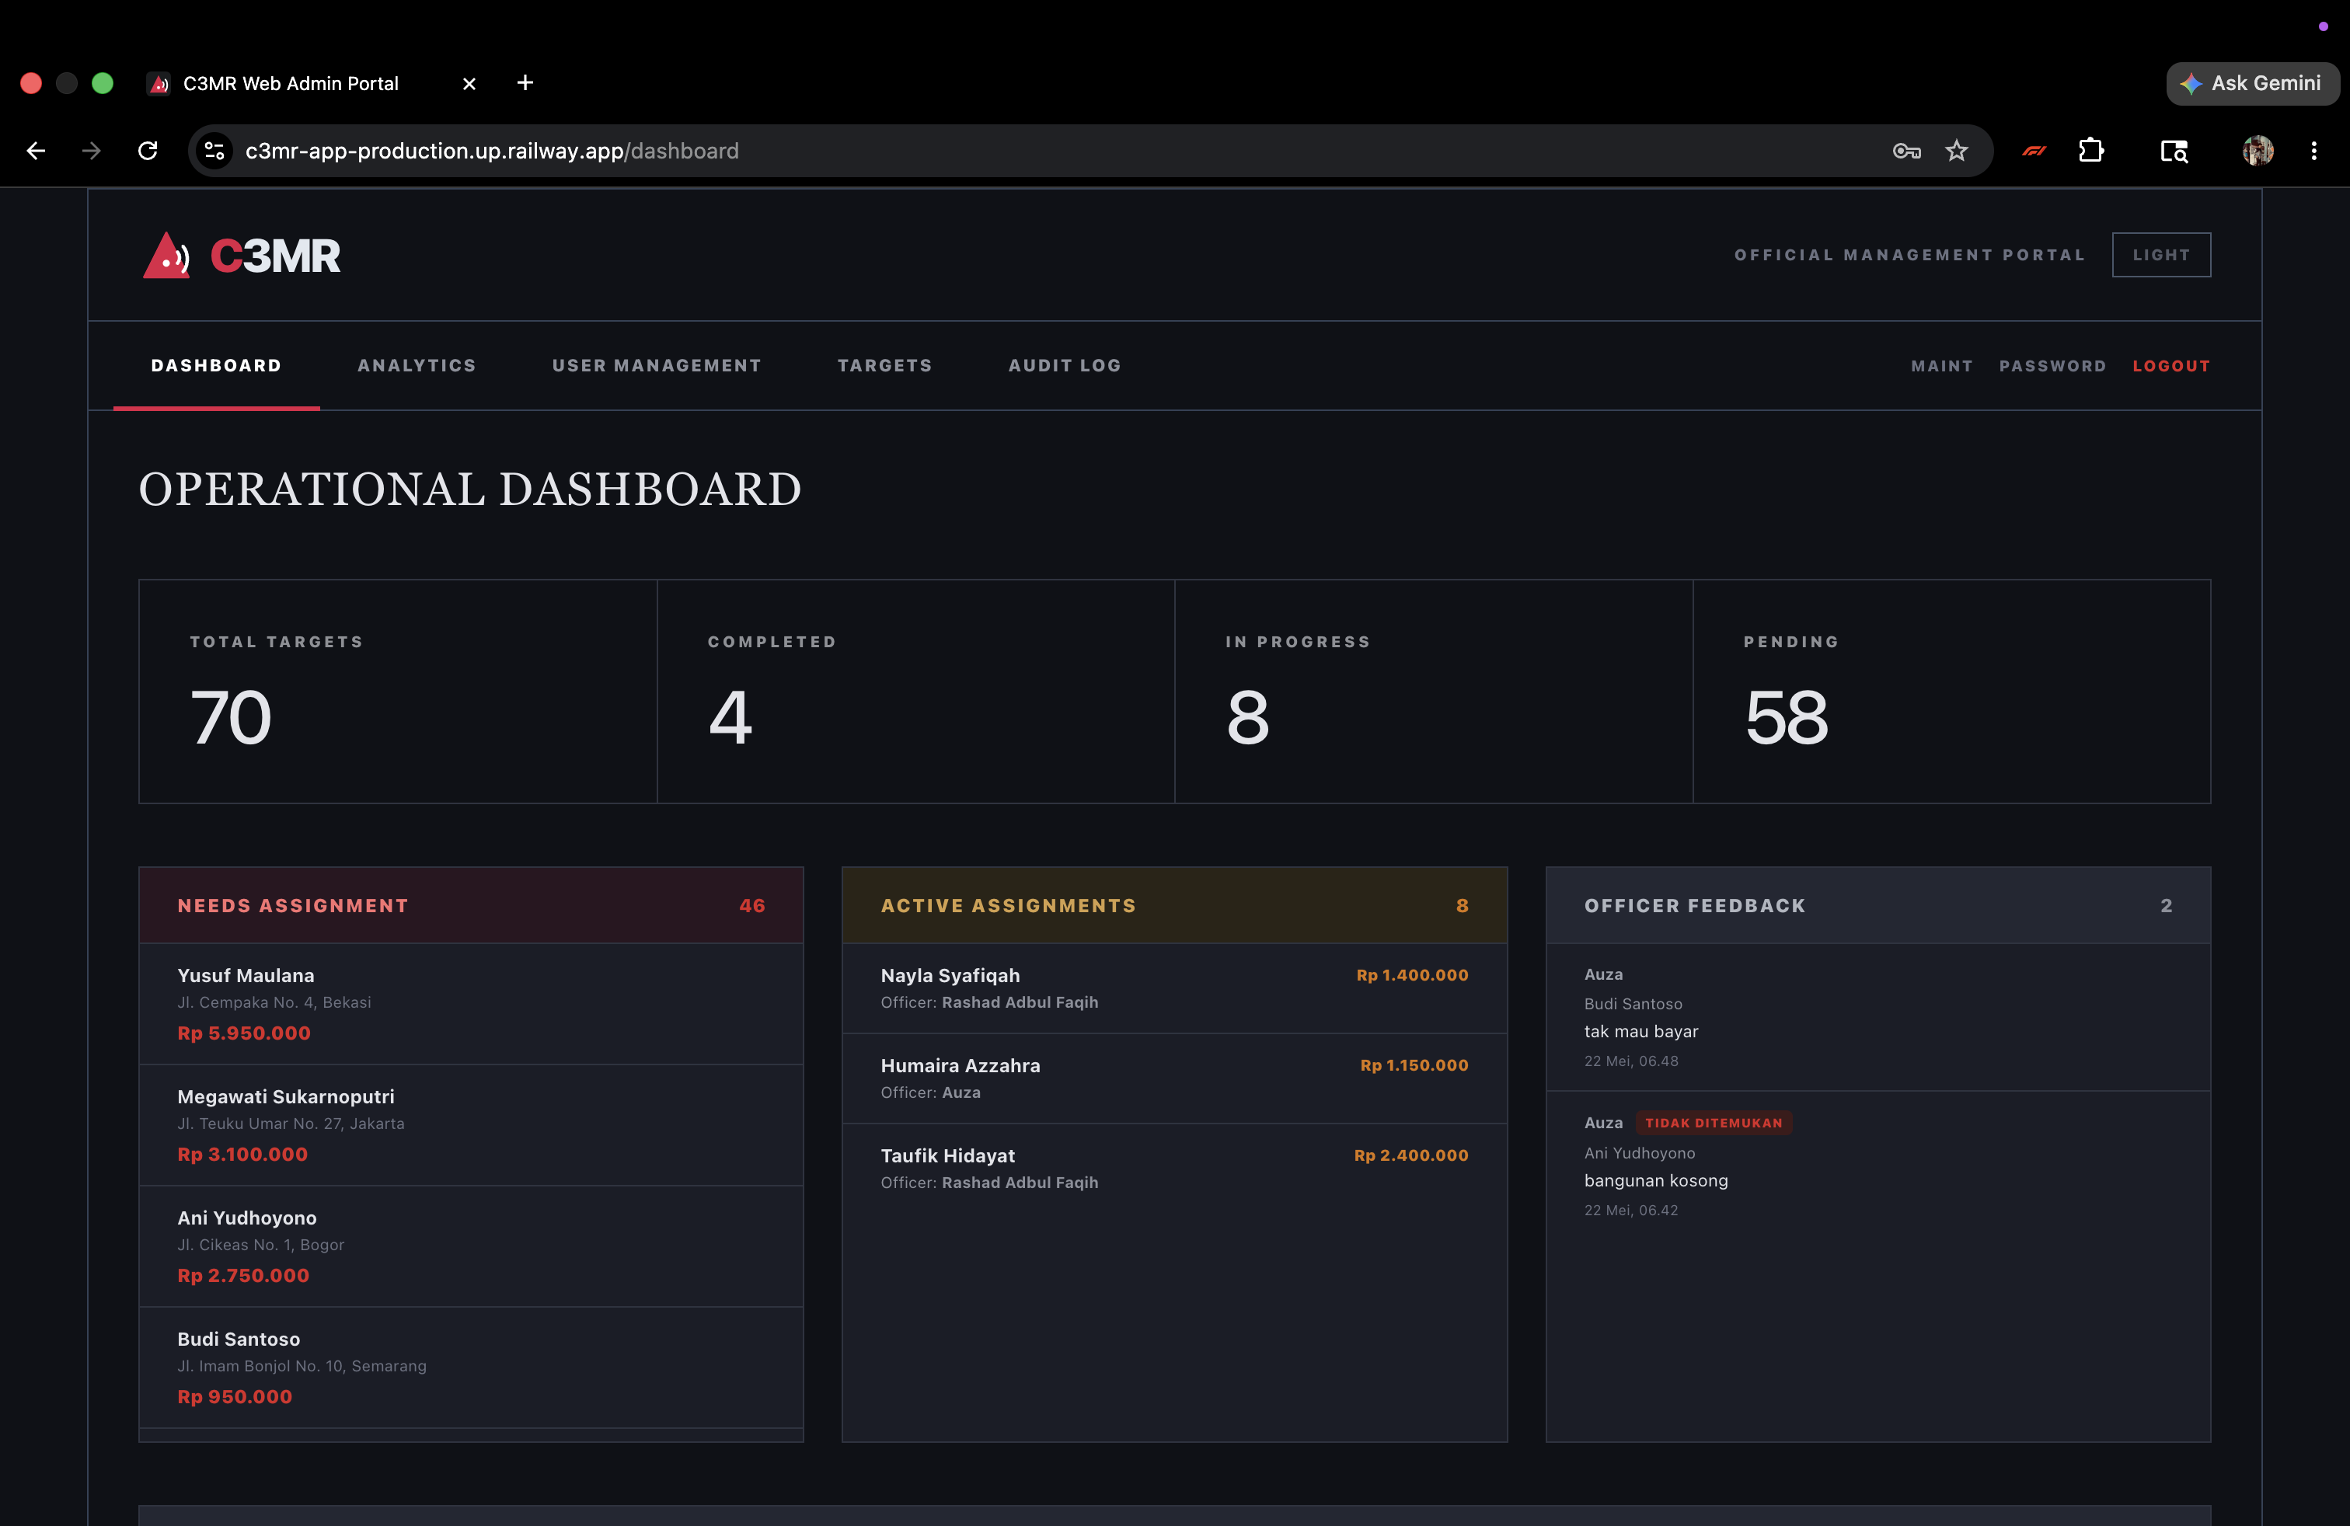
Figure B.1k — Web Admin Portal — Dark Mode
Dark mode toggle available in header (desktop: Dark/Light button, mobile: DK/LT). Theme preference persisted in localStorage. CSS custom properties with global .dark class overrides ensure consistent dark theme across all pages without modifying individual components.

2. View Dashboard: Four summary cards show target counts. Recent comments section shows latest officer feedback.
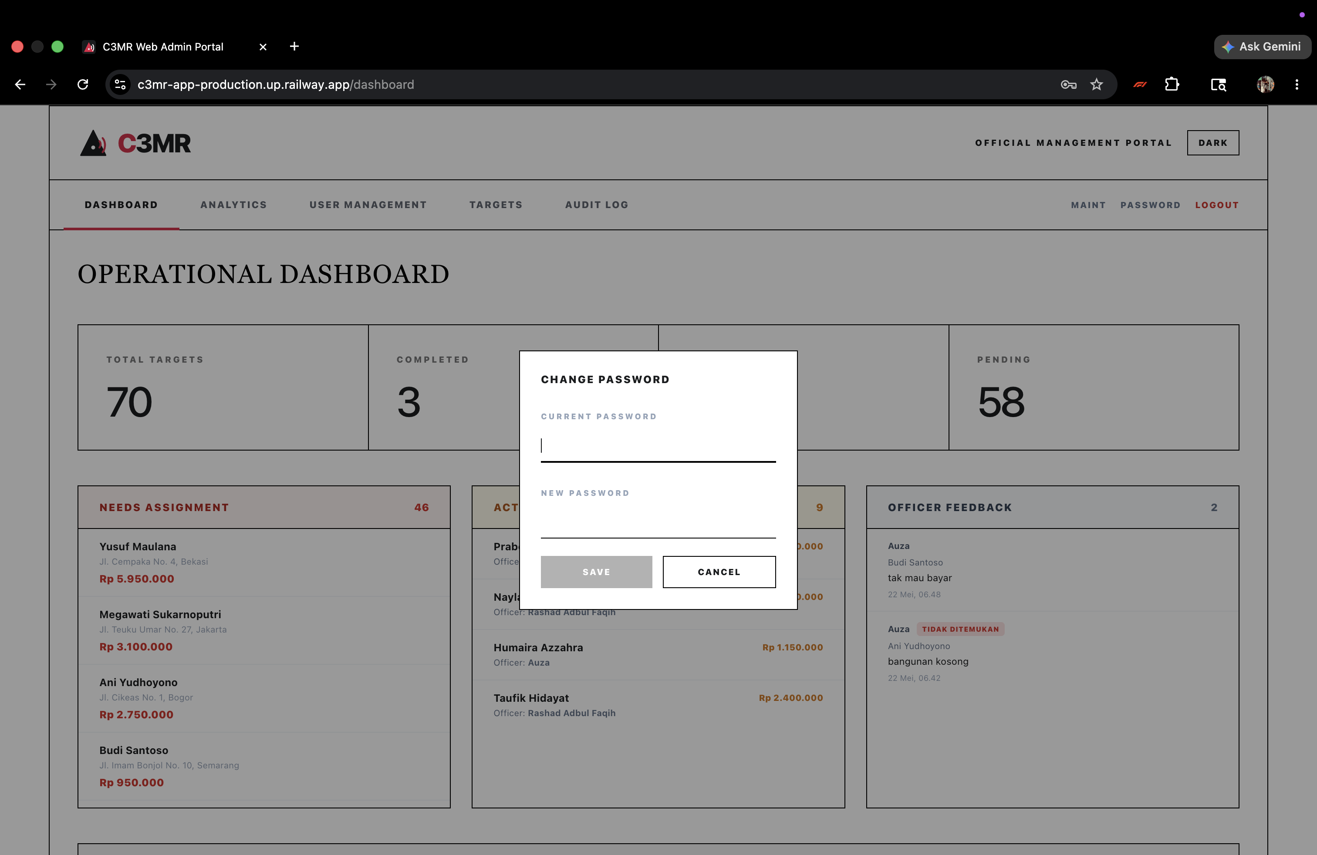
Figure B.1l — Web Admin Portal — Change Password Modal
Accessible from navigation bar. Requires current password verification before allowing change. Minimum 6-character new password. Action logged to audit trail.

/start: Welcome message with system description and 'Open Field App' inline button.
3. Upload CSV Targets: Use the CSV Upload panel. CSV must have columns: customer_name, address, phone, amount_due. Preview before confirming upload.
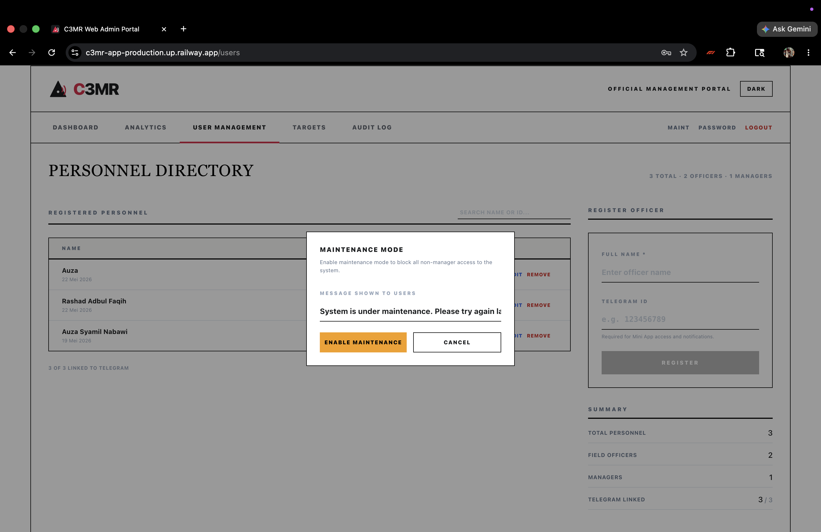
Figure B.1m — Web Admin Portal — Maintenance Mode
Manager can enable maintenance mode from the navigation bar. When active, an amber banner appears at the top of the page. All non-manager API requests receive HTTP 503.

/summary: Collection statistics — target counts, revenue totals, active officers.
4. Assign Officer: Click 'Assign' on unassigned targets, select officer from dropdown. Officer receives Telegram notification automatically.
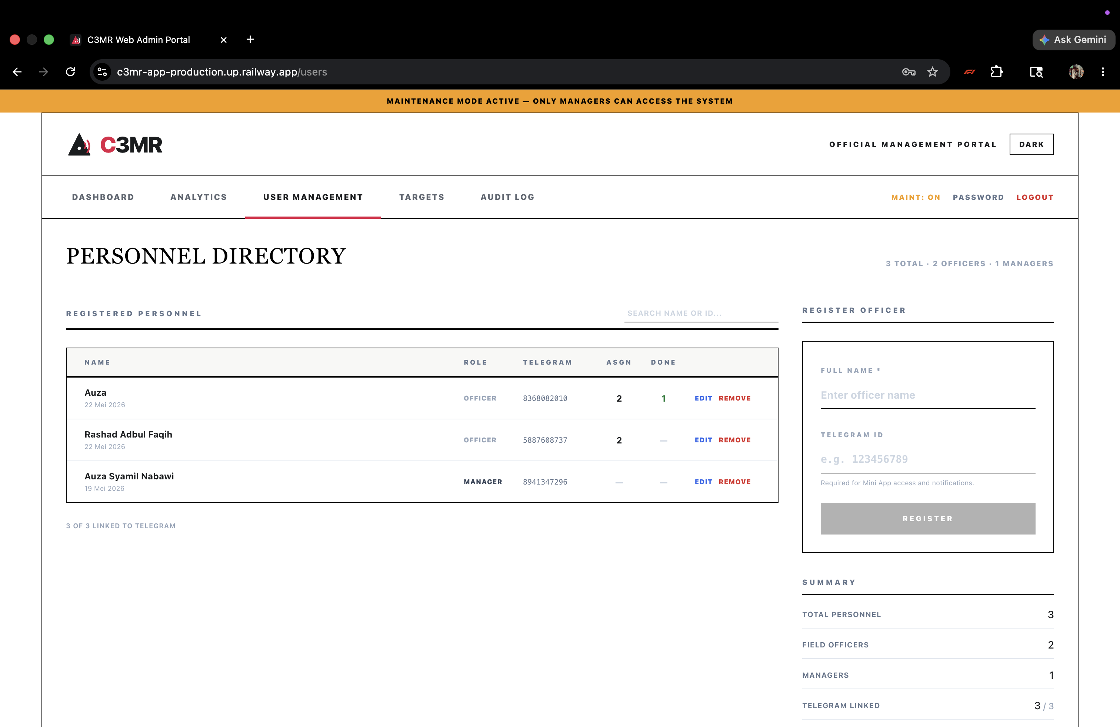
Figure B.1n — Web Admin Portal — Maintenance Banner Active

B.2 Telegram Mini App
/officers: List of all officers with their assigned task counts.
5. View Details & Comments: Click 'View Details' to see full target info and officer comments with issue tags.
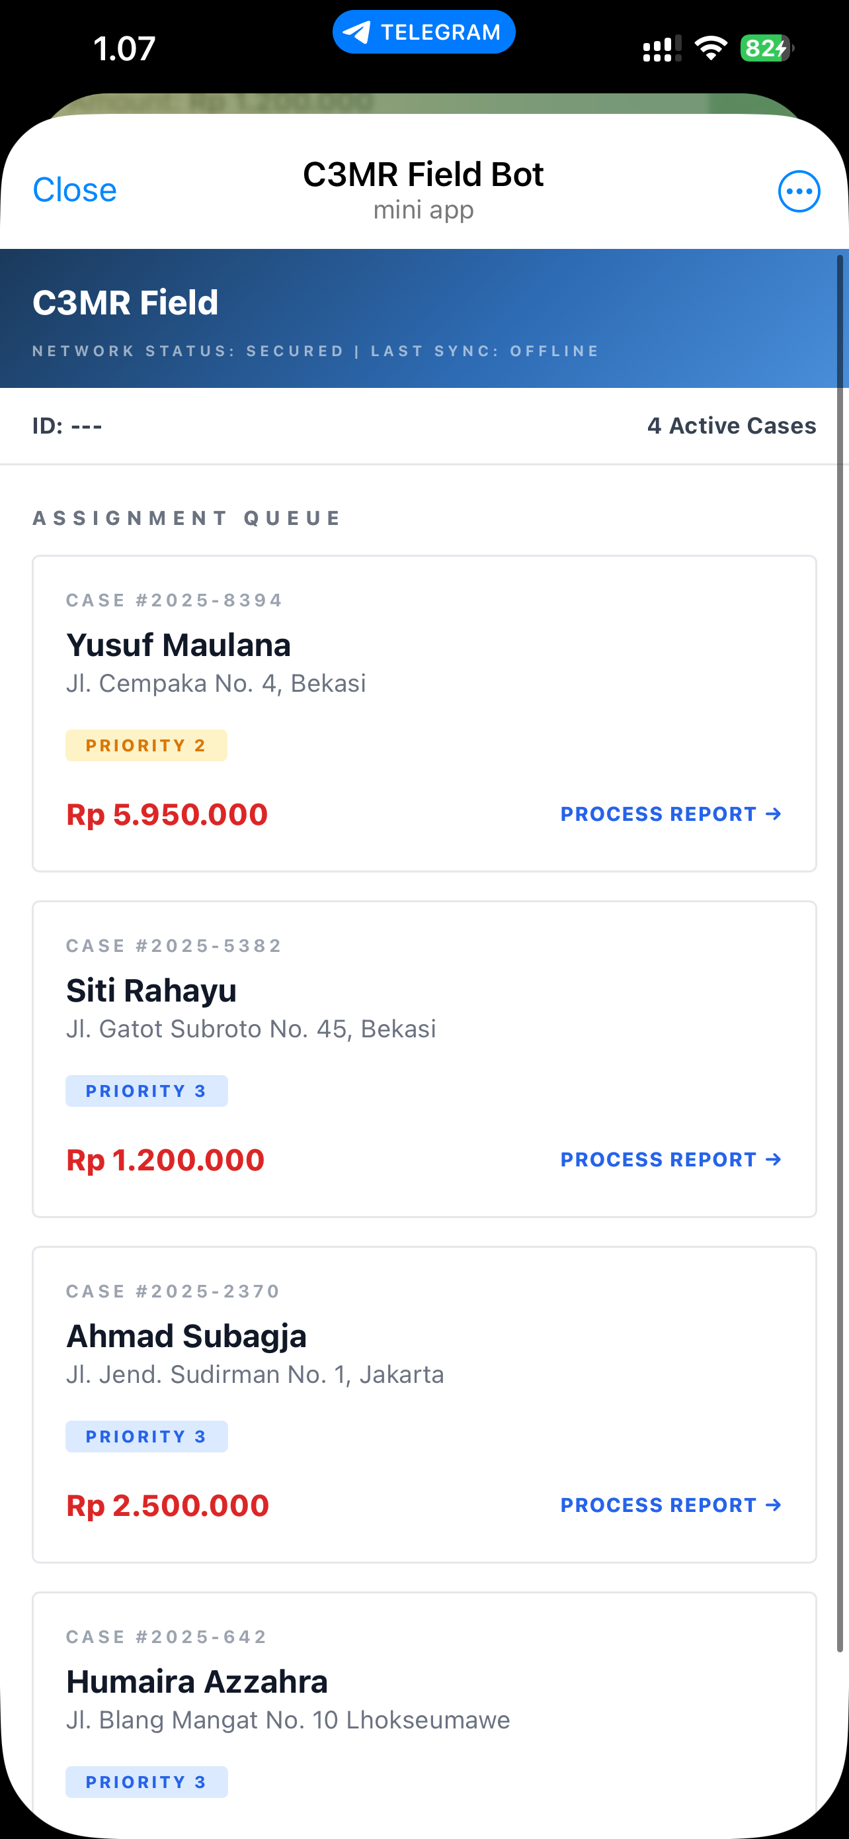
Figure B.2a — Mini App — Task List (left) and Report Submission (right)
Left: Assignment queue with task cards showing case number, priority badges (Priority 1/2/3), customer info, and amount. Right: Report form with classification dropdown, officer narrative, photo capture, and 'Finalize Submission' button.

6. Analytics: Navigate to Analytics page for revenue overview, status breakdown, officer performance ranking, and activity summary. Use date range filter (from/to) to analyze specific periods.
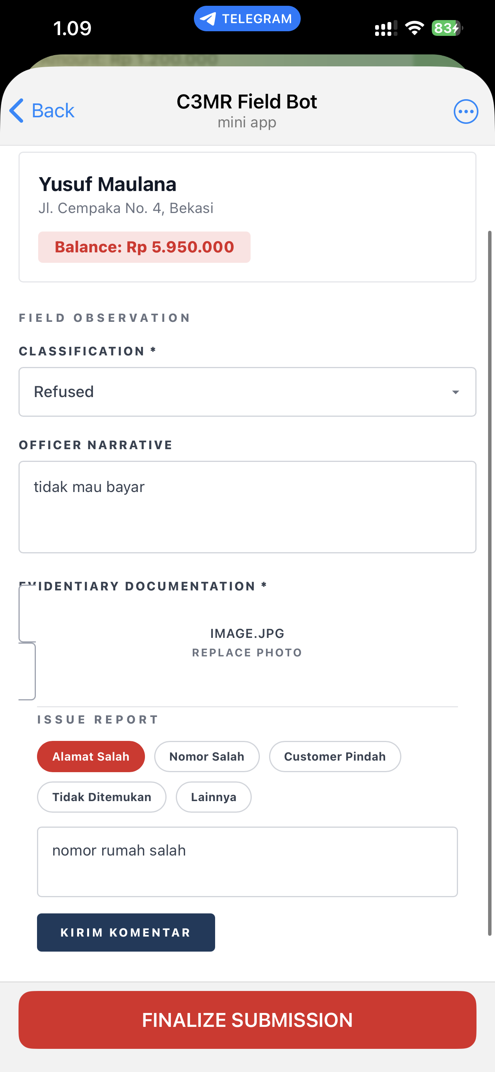
Figure B.2b — Mini App — Comment System and Issue Reporting

7. Manage Users: User Management page: add officers with name/Telegram ID. Edit or remove officers (requires password confirmation). Cannot delete officers with assigned data (must reassign first).
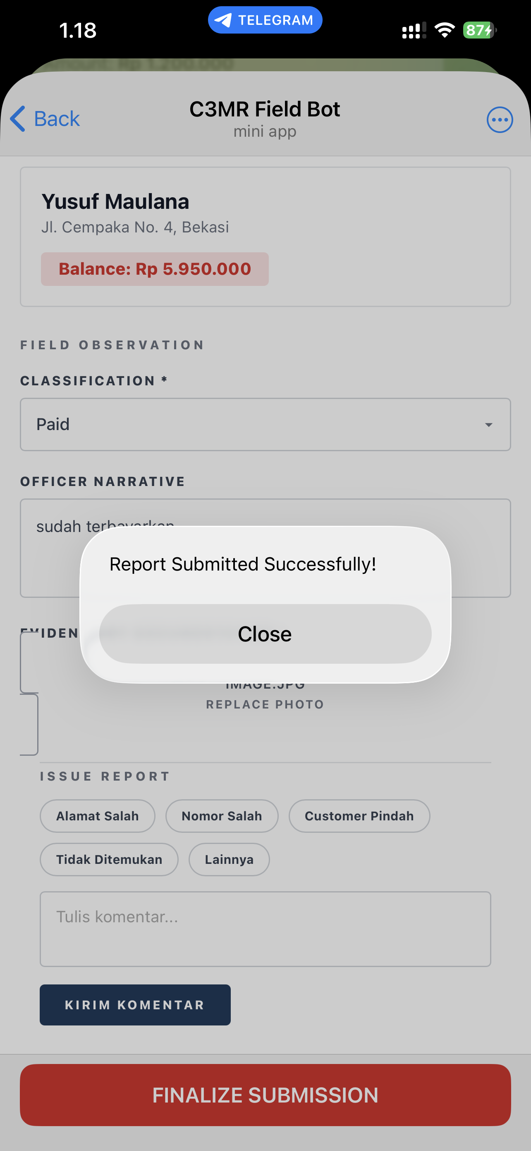
Figure B.2c — Mini App — Submission Success

B.3 Telegram Manager Bot
8. Export CSV: On Targets page, click 'Export CSV' to download all target records as a spreadsheet.
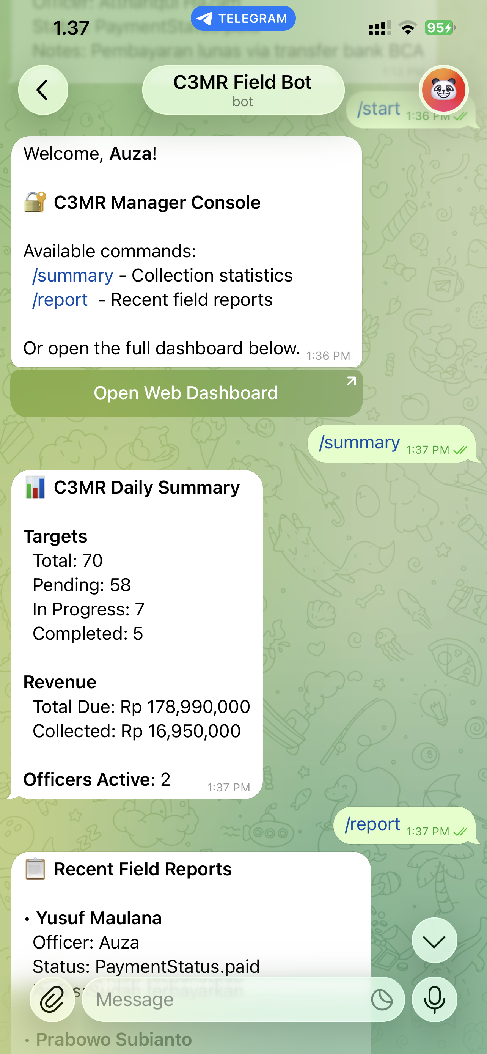
Figure B.3a — Manager Bot — Notifications and /summary Command
Shows submission field reports with case ID, subject, status, and officer name. The /generate_daily_summary command displays operational summary with period, total units, completed count, and active percentage.

C. COMPONENT COST ANALYSIS
The following table lists all necessary components for the C3MR system to operate in production.
No. | Item | Unit | Price per Unit | Total
1 | Railway Starter Plan  (Backend + Frontend + Bot) | 2 services/mo | $5/mo (~Rp 80,000) | Rp 80,000/mo
2 | Railway PostgreSQL  (Database add-on) | 1 instance | Included in plan | Rp 0
3 | Telegram Bot API | 1 bot | Free | Rp 0
4 | Custom Domain  (optional) | 1 year | ~Rp 150,000/yr | Rp 150,000/yr
5 | Development Laptop  (existing hardware) | 1 unit | Existing asset | Rp 0
6 | ngrok Free Tier  (development only) | 1 account | Free | Rp 0
7 | IDE & Dev Tools  (VS Code, Postman, Git) | Per developer | Free/Open Source | Rp 0

Total Estimated Monthly Cost: Rp 80,000/month (~$5 USD)
Total Estimated First-Year Cost: Rp 1,110,000 (~$69 USD)

D. FUNCTIONAL TESTING
Each feature is tested with both manual scenario testing (Section D.1) and an automated pytest test suite (Section D.2). The automated suite contains 20 test cases covering authentication, user management, target operations, dashboard, analytics, comments, security enforcement, RBAC, and FK cascade protection.

D.1 Manual Scenario Testing

Test 1: Manager Login Process
No. | Scenario | Every Possible Input | Expected Output | Result
1 | Valid credentials | Username: admin  Password: password123 | Redirect to Dashboard | PASS
2 | Wrong password | Username: admin  Password: wrongpass | Error: Invalid credentials  (4 attempts remaining) | PASS
3 | Empty fields | Username: (empty)  Password: (empty) | HTML5 validation blocks  submission | PASS
4 | Brute force (5 failures) | Wrong password 5 times | Account locked 60 seconds  Form disabled | PASS
5 | Lockout recovery | Wait 60 seconds after lock | Form re-enabled  Can try again | PASS

Test 2: Upload CSV Targets
No. | Scenario | Every Possible Input | Expected Output | Result
1 | Valid CSV | CSV with customer_name,  address, phone, amount_due | Targets imported,  appear in table | PASS
2 | Empty CSV | Headers only, no data | 0 records parsed | PASS
3 | Missing column | CSV without amount_due | Error: Missing required  columns: amount_due | PASS
4 | Non-CSV file | Upload .txt file | Error: Only .csv files  accepted | PASS

Test 3: Assign Officer to Target
No. | Scenario | Every Possible Input | Expected Output | Result
1 | Assign to target | Click Assign, select officer | Status → In Progress | PASS
2 | Officer with Telegram | Assign officer with telegram_id | Notification sent to officer | PASS
3 | Officer without Telegram | Assign officer, no telegram_id | Assignment OK, no notif | PASS

Test 4: Officer Views Task List (Mini App)
No. | Scenario | Every Possible Input | Expected Output | Result
1 | Open from Telegram | Tap Menu button in bot chat | Task list with priority cards | PASS
2 | Registered officer | Officer with telegram_id in DB | Cards with priorities shown | PASS
3 | Unregistered user | Unknown telegram_id | Error: Akses Ditolak | PASS
4 | No assigned tasks | Officer with 0 targets | 'No pending assignments' | PASS

Test 5: Officer Submits Report (Mini App)
No. | Scenario | Every Possible Input | Expected Output | Result
1 | Complete report | Classification + Notes +  Photo attached | Success alert, list refreshed | PASS
2 | No photo | Classification + Notes,  no photo | Error: Photo mandatory | PASS
3 | Status: Paid | Classification = Paid | Target → Completed | PASS
4 | Status: Refused | Classification = Refused | Target stays In Progress | PASS

Test 6: Officer Issue Comment (Mini App)
No. | Scenario | Every Possible Input | Expected Output | Result
1 | Comment with tag | Tag: Alamat Salah  Message: filled | Saved with tag badge | PASS
2 | Comment no tag | Tag: none  Message: filled | Saved without badge | PASS
3 | View in web admin | Manager opens target details | Comment with officer name shown | PASS
4 | Empty comment | Tag: selected  Message: empty | Error: Tulis komentar | PASS

Test 7: Manager Dashboard
No. | Scenario | Every Possible Input | Expected Output | Result
1 | Dashboard load | Navigate to /dashboard | Stats cards + table shown | PASS
2 | Filter by status | Select 'Pending' filter | Only pending targets shown | PASS
3 | Analytics page | Navigate to /analytics | Charts + revenue displayed | PASS
4 | Recent comments | Dashboard feed section | Latest 5 comments with names | PASS

Test 8: Manager Bot Commands
No. | Scenario | Every Possible Input | Expected Output | Result
1 | /start | Send /start to bot | Welcome + Open App button | PASS
2 | /summary | Send /summary | Stats: counts, revenue | PASS
3 | /officers | Send /officers | Officer list with task counts | PASS
4 | Unauthorized user | Non-manager sends /summary | Access Denied message | PASS

Test 9: User Management

Test 10: Export CSV
No. | Scenario | Every Possible Input | Expected Output | Result
1 | Export all targets | Click 'Export CSV' button | CSV file downloaded with  all target records | PASS
2 | CSV content | Open downloaded file | Columns: customer_name,  address, phone, amount_due,  status, officer | PASS
3 | Empty database | Export with no targets | Empty CSV with headers only | PASS

Test 11: Bulk Assign Officers
No. | Scenario | Every Possible Input | Expected Output | Result
1 | Select multiple targets | Check 3 pending targets | Blue bar shows '3 selected' | PASS
2 | Bulk assign | Select officer, click  'Assign All' | All 3 targets → In Progress  Officer notified | PASS
3 | No officer selected | Click 'Assign All' without  selecting officer | Button disabled | PASS
4 | Select all | Click header checkbox | All pending targets selected | PASS
5 | Clear selection | Click 'Clear' | All checkboxes unchecked  Blue bar disappears | PASS

Test 12: Change Password
No. | Scenario | Every Possible Input | Expected Output | Result
1 | Valid change | Correct current password  + new password (6+ chars) | Success message  Password updated | PASS
2 | Wrong current password | Incorrect current password | Error: Current password  is incorrect | PASS
3 | Short new password | New password: 'abc' | Error: Min 6 characters | PASS
4 | Empty fields | Both fields empty | Button disabled | PASS

Test 13: Audit Log & Notifications
No. | Scenario | Every Possible Input | Expected Output | Result
1 | View activity log | Navigate to Audit Log page | List of actions with  actor names, timestamps | PASS
2 | View notifications | Click 'Notifications' tab | List of sent notifications  with Sent/Failed badges | PASS
3 | After assign action | Assign officer, check log | New 'assign' entry appears  with target and officer detail | PASS
4 | After delete user | Delete user, check log | New 'delete_user' entry  with user name | PASS

Test 14: Dark Mode Toggle
No. | Scenario | Every Possible Input | Expected Output | Result
1 | Toggle dark mode | Click 'Dark' button  in header | All pages switch to  dark theme | PASS
2 | Toggle back to light | Click 'Light' button | All pages return to  light theme | PASS
3 | Persistence | Enable dark, refresh page | Dark mode persists  (saved in localStorage) | PASS
4 | Mobile toggle | Tap 'DK' button on mobile | Dark mode activates | PASS

Test 15: Session Timeout (5 Minutes Idle)
No. | Scenario | Every Possible Input | Expected Output | Result
1 | Active usage | Interact within 5 minutes | Session remains active | PASS
2 | Idle timeout | No interaction for  5 minutes | Auto-logout, redirect  to login page | PASS
3 | Timer reset | Move mouse after 4 minutes | Timer resets, session  continues | PASS

Test 16: Password Confirmation for Edit/Delete

Test 17: Maintenance Mode
No. | Scenario | Every Possible Input | Expected Output | Result
1 | Enable maintenance | Click 'Maint' → 'Enable  Maintenance' | Amber banner appears  API returns 503 to non-managers | PASS
2 | Custom message | Enter custom message  before enabling | 503 response contains  custom message text | PASS
3 | Manager still works | Navigate pages while  maintenance is ON | All pages load normally  for logged-in manager | PASS
4 | Officer blocked | Officer opens Mini App  during maintenance | 503 error / access denied | PASS
5 | Disable maintenance | Click 'Disable  Maintenance' | Banner disappears  Officers can access again | PASS
No. | Scenario | Every Possible Input | Expected Output | Result
1 | Edit with correct password | Click Edit, enter correct  password | Edit modal opens | PASS
2 | Delete with correct password | Click Remove, enter  correct password | User deleted from table | PASS
3 | Wrong password | Enter incorrect password | Error: Invalid password | PASS
4 | Cancel confirmation | Click Cancel on modal | Modal closes, no action | PASS
No. | Scenario | Every Possible Input | Expected Output | Result
1 | Add officer | Name + Telegram ID | Appears in user table | PASS
2 | Duplicate Telegram ID | Existing telegram_id | Error: Already registered | PASS
3 | Remove officer (no data) | Click Remove, confirm | Deleted from table | PASS
4 | Remove officer (has data) | Officer with assigned targets | Error 409: Cannot delete  user with assigned data | PASS
5 | Officer access denied | Login as officer,  access /users/ | HTTP 403 Forbidden | PASS

D.2 Automated Test Suite (pytest) — 20 Test Cases
The project includes 20 automated API tests using pytest with FastAPI TestClient. Tests run against an in-memory SQLite database (StaticPool) that is created fresh for each test function, ensuring complete isolation. All tests include JWT authentication headers via the auth_headers fixture.

Test Configuration (backend/tests/conftest.py)
engine = create_engine("sqlite:///:memory:", poolclass=StaticPool)
# Override dependency: all endpoints use test DB
app.dependency_overrides[get_db] = override_get_db
# Fixture: fresh tables for each test
@pytest.fixture(scope='function', autouse=True)
def setup_db():
Base.metadata.create_all(bind=engine)
yield
Base.metadata.drop_all(bind=engine)
# auth_headers fixture: creates manager, logs in, returns JWT

Test Coverage (20 tests)
- Authentication (5 tests): seed admin (valid/invalid token), valid login, wrong password, nonexistent user
- User Management (3 tests): create/list, duplicate telegram_id rejection, delete user
- Targets (3 tests): upload/list, pagination (skip/limit), assign officer with status change
- Dashboard (2 tests): snapshot stats, recent comments with joined query
- Analytics (1 test): summary with revenue breakdown and distribution
- Comments (1 test): target comments with officer name
- Security (3 tests): officer tasks/report/comment without auth → 401 Unauthorized
- RBAC (1 test): officer login then access /users/ → 403 Forbidden
- FK Safety (1 test): delete user with assigned targets → 409 Conflict

Result: 20 passed, 0 failed.

E. MANUAL GUIDE

E.1 System Build Documentation from the Source
Developer perspective: tools, dependencies, and steps to build and run C3MR from source.

Prerequisites
- Python 3.10+ (recommended 3.12+)
- Node.js 18+ with npm
- Git version control
- Telegram account (for bot/Mini App testing)

Backend Setup
- Clone the repository: git clone https://github.com/asn95/capstone1.git
- Navigate to backend directory: cd capstone1/backend
- Create Python virtual environment: python3 -m venv venv && source venv/bin/activate
- Install dependencies: pip install -r requirements.txt
- Configure environment variables: copy .env.example to .env and set DATABASE_URL, SECRET_KEY, TELEGRAM_BOT_TOKEN
- Initialize database: the application auto-creates tables on first run via SQLAlchemy
- Run the backend server: uvicorn backend.main:app --host 0.0.0.0 --port 8000

Frontend Setup
- Navigate to frontend directory: cd capstone1/frontend
- Install dependencies: npm install
- Configure API base URL in environment variables to point to the backend server
- Run development server: npm run dev
- Build for production: npm run build (outputs to dist/ directory)

Production Deployment (Railway)
- Create a Railway project and provision a PostgreSQL database
- Deploy the web application service (c3mr-app) using the Dockerfile — serves both backend API and frontend static files
- Deploy the bot service (c3mr-bot) using Dockerfile.bot — runs the Telegram Manager Bot independently
- Set environment variables on Railway: DATABASE_URL (auto-provisioned), SECRET_KEY, TELEGRAM_BOT_TOKEN, MINI_APP_URL
- Configure custom domain or use the Railway-provided public URL

E.2 End-User System Installation
C3MR is a web-based system that requires no local installation for end users. Access details per role:
- Manager (Web Admin Portal): Open the deployed URL in any modern web browser (Chrome, Firefox, Safari, Edge). Log in with credentials provided by the system administrator.
- Field Officer (Telegram Mini App): Open the Telegram messaging app on a mobile device. The Mini App is accessed directly from the bot chat — no separate installation is required.
- Manager (Telegram Bot): Search for the C3MR Manager Bot in Telegram and start a conversation with /start. The bot responds to commands within the chat.

E.3 User Guide Per User Role

Role 1: Manager — Web Admin Portal
- Login: Enter username and password on the login page. Failed attempts are rate-limited (5 per minute).
- Dashboard: View real-time collection statistics — total targets, total collected, collection rate, and officer performance charts.
- Target Management: Upload CSV files of collection targets, view/filter/search targets, assign individual or bulk targets to officers.
- Analytics: View detailed charts for payment status distribution, officer workload comparison, and trend analysis.
- User Management: Create, edit, or delete officer accounts. Password confirmation is required for edit and delete operations.
- Audit Log: Review all administrative actions (Activity tab) and Telegram notification delivery status (Notifications tab).
- Settings: Toggle dark mode, change password, and enable/disable maintenance mode.

Role 2: Field Officer — Telegram Mini App
- Access: Open the Mini App from the Telegram bot menu button. Authentication is automatic via Telegram identity verification.
- Task List: View all assigned collection targets with status indicators. Tap a target to view details.
- Submit Report: For each target, fill in the collection amount, payment status, and optional proof photo. Submit to record the visit.
- Issue Reporting: If unable to collect, use the comment/issue feature to report reasons (e.g., customer not home, disputes).

Role 3: Manager — Telegram Bot
- /start — Initialize the bot and receive a welcome message.
- /summary — View a real-time summary of collection progress: total targets, reports submitted, collection rate, and officer count.
- /report — View the latest field reports with details: officer name, customer name, amount, payment status, and timestamp.
- Real-time Notifications: The bot automatically sends notifications when officers submit reports or flag issues.

REFERENCES

Bray, T. (Ed.). (2017). The JavaScript Object Notation (JSON) Data Interchange Format (RFC 8259). Internet Engineering Task Force. https://datatracker.ietf.org/doc/html/rfc8259
Jones, M., Bradley, J., & Sakimura, N. (2015). JSON Web Token (JWT) (RFC 7519). Internet Engineering Task Force. https://datatracker.ietf.org/doc/html/rfc7519
Krawczyk, H., Bellare, M., & Canetti, R. (1997). HMAC: Keyed-Hashing for Message Authentication (RFC 2104). Internet Engineering Task Force. https://datatracker.ietf.org/doc/html/rfc2104
Meta Open Source. (2024). React: A JavaScript library for building user interfaces. https://react.dev/
OWASP Foundation. (2021). OWASP Top Ten 2021. https://owasp.org/Top10/2021/
Provos, N. & Mazières, D. (1999). A future-adaptable password scheme. In Proceedings of the USENIX Annual Technical Conference. https://www.usenix.org/legacy/events/usenix99/provos.html
Pydantic. (2024). Pydantic: Data validation using Python type annotations. https://docs.pydantic.dev/
PyJWT. (2024). PyJWT: JSON Web Token implementation in Python. https://pyjwt.readthedocs.io/
Ramírez, S. (2024). FastAPI: Modern, fast web framework for building APIs with Python. https://fastapi.tiangolo.com/
SQLAlchemy. (2024). SQLAlchemy: The Python SQL toolkit and Object Relational Mapper. https://www.sqlalchemy.org/
Tailwind Labs. (2024). Tailwind CSS: A utility-first CSS framework. https://tailwindcss.com/
Telegram. (n.d.). Telegram Bot API. https://core.telegram.org/bots/api
Vite. (2024). Vite: Next generation frontend tooling. https://vitejs.dev/
bcrypt. (2024). bcrypt: Modern password hashing for your software. https://pypi.org/project/bcrypt/
pytest. (2024). pytest: Simple powerful testing with Python. https://docs.pytest.org/
python-telegram-bot. (2024). python-telegram-bot: A Python wrapper for the Telegram Bot API. https://python-telegram-bot.readthedocs.io/
Role | Hardware/Software | Network | Access
Managers  (Web Admin Portal) | Computer/tablet with modern browser  (Chrome, Firefox, Safari, Edge) | Stable internet (min 1 Mbps) | Navigate to deployed URL,  login with username/password
Field Officers  (Telegram Mini App) | Android/iOS smartphone  with camera | Mobile data or Wi-Fi | Open bot in Telegram,  tap Menu button
Managers  (Telegram Bot) | Smartphone with  Telegram app | Mobile data or Wi-Fi | Search bot, send /start

